Jiu-Jitsu Is Chess – Or How to Win Grappling Titles Training 2 Hours a Week

Table of Contents

Chapter 0: Introduction 3

Who Am I and Why Did I Write This Book? 3

What This Book Is and What It Isn’t 4

The Importance of Making Your Time Count 5

Jiu-Jitsu is Chess 5

Start a Training Log 6

Chapter 1: Master a Submission 6

The Importance of Submissions 6

Choose a Primary Submission 7

Theory: Offense vs Defense in Jiu-Jitsu 7

The Myth of Variety 8

Choosing a Primary Submission: The Criteria 9

How it Works: The Specifics 11

To Beat Someone Better Than You… 14

The Advantage in Competition 14

Examples at the Top 14

Building an Offensive Sequence 15

Offense Is the Best Defense 15

Chapter Summary 16

Chapter 2: Gameplanning 101 16

A Game-What? 16

The Purpose of a Gameplan: Get to Your Primary Submission 17

Build a Primary Offensive Path 17

The Rest of Your Gameplan: Getting Derailed 18

Summary So Far 20

Alternative Attacks 20

Combinations 20

Synergy 23

Chapter Summary 24

Chapter 3: The Shortcut to Learning Defense – Think Mechanically 24

Joint Locks 25

Chokes 25

Application 26

Triangles 26

Armbars 28

Chapter Summary 31

Chapter 4: Putting It into Practice – You Fight the Way You Train 31

Competition Preparation Rolls – 50% of Your Training 31

Use Your Competition Gameplan in 90% of All Rolls 32

Rolling With Less-Skilled Partners 32

Rolling is the Best Form of Practice 32

Learn to Stay Technical Under Pressure 33

What to Write in Your Training Log 33

Chapter Summary 33

Chapter 5: Competition Mindset 34

Stay Relaxed – You’re Just Rolling With Someone New 34

Trust Your Gameplan 34

Mental Preparation for the “Big” Day 35

How to Avoid Negative Visualization, or “Disaster Dreaming”: 35

My Story: Winning the Largest Jiu-Jitsu Competition in Chicago 36

Chapter Summary 38

Ending 38

# Chapter 0: Introduction

## Who Am I and Why Did I Write This Book?

My name is Matthew Chan and I’m a part-time jiu-jitsu athlete. If you purchased this book with the intention of improving your existing BJJ game, you made a good choice. As far as I know, no other product exists out there to help you streamline your game, for *you*, the way that this book does.

Most jiu-jitsu books out there are technical manuals teaching you the fundamentals of the art. Or they’re written by full-time professionals who share tips and tricks for competition and their unique techniques. And while those are all great resources, none of them are written by someone in the position of most BJJ athletes and none of them address the problem that most jiu-jitsu practitioners face – limited training time.

How do you win competitions as a part-time athlete when even white belts train 5 days a week nowadays?

You can’t beat them on time. You live a busy and full life outside of jiu-jitsu, but you don’t want to lose ground in a sport that’s becoming increasingly competitive.

If you can’t train more than your competition, you have to train smarter. That’s what this book teaches you how to do.

You see, I was once in your shoes. I wanted to win competitions, but I wasn’t in a position to train full-time. In my first two competitions, I won some matches but lost in the end to opponents who had put in more mat time than me.

The thing about me though, is that I hate losing. I racked my brain for answers. What could I do? Was I going to drop out of school to train full-time? I’m not going to lie – part of me wanted to – but I knew I couldn’t do that.

Instead, I decided that if I wasn’t going to be able to put in as many hours at the gym as my competition, I would have to make every hour I spent training count that much more.

And from that idea was born this book.

In the following sections, you will learn how to optimize your jiu-jitsu game and structure your training based on strategic principles that have brought me consistent results in competition and that are used by pros all the way up to World’s.

Have you ever wondered how Roger Gracie is able to beat everyone he faces with the same three moves, over and over again? I explain this in **Chapter 1: Master a Submission** and how I used the same principle to become known as the “triangle man” in my home jiu-jitsu gym.

What I’m about to share with you is the product of years of thought and experience on the subject of winning BJJ competitions while training as a part-time athlete.

That being said, let’s delve into what this book is and what this book isn’t.

## What This Book Is and What It Isn’t

**What This Book Isn’t**

This book isnota technical manual. There are plenty of people who can teach techniques better than I can through a book and if you want a place to learn them, I recommend youtube. The internet is a vast library of BJJ techniques and a resource you absolutely should be using to improve your game.

So what are you going to learn from reading this, if not techniques?

**What This Book Is**

This book is a strategy guide that will guide your development as an athlete in terms of how you train, what you train, how you gameplan, and how you compete. If it sounds like I’m trying to dictate your development as an athlete, rest assured – the specifics are up to you to decide on. It’s the principles that apply to everyone.

You will learn new ways of thinking about and training BJJ that will give you an edge over someone who is not aware of these ideas. You will “hack” your development as an athlete by employing specific strategies that apply your limited time and energy to where it counts the most.

If at the end of reading this, you feel that you haven’t gained any value from this book, feel free to email me with a receipt within 30 days of purchase and I will give you a free refund. But I can promise you that if you take the time to understand and apply the concepts presented in this book, you will see your development as a BJJ athlete occur like it has never before.

## The Importance of Making Your Time Count

What makes the difference between someone who trains BJJ for five years and is mediocre at best and someone who’s been training for less than two years but is already tapping out higher-level belts and looks like the second coming of Marcelo Garcia? If you train at a typical gym, you can probably already think of specific examples of both. Maybe you’re even one of them.

Does the difference lie in mat time? I would say that it’s a factor. If you’re training four times a week, you will have an advantage over someone training once a week. But I’ve beaten people who put in more mat time than me and I’m sure you can remember a time where you beat someone who had more training time than you, or vice versa.

For an extreme example, look up *Dai Yoshioka* – a BJJ competitor who won Bronze and Silver at World’s as a black belt while working full-time as a doctor. I can guarantee you that he wasn’t training even half as often as your typical professional athlete, and yet he was able to compete and win against the best in the world. How?

There’s a much more important factor than mat time at play in determining the rate of a jiu-jitsu athlete’s development, and it’s this: the successful BJJ athlete has learned how to ***focus******their training***.

It’s that simple. Maximizing your training time as it relates to your development as a BJJ athlete really is all about focusing your training, and this entire book is dedicated to teaching you how to do this.

**What Do I Mean By ‘Focus’?**

What you have to realize is that you only get better at jiu-jitsu – and at anything really, by making progress in a ***specific*** direction, consistently, for an extended period of time.

Training a bit of everything gets you nowhere. You have to learn to apply your training time and effort into the few techniques or exercises that pay off the most, rather than learning a bit of everything like most beginners at BJJ. This is what I refer to when I use the word *focus*.

The idea of focus will be a recurring theme throughout this book. By the end of it, you will realize exactly what it means as it pertains to jiu-jitsu and how to implement this idea to make an astounding difference in your development as a grappling athlete.

## Jiu-Jitsu is Chess

Jiu-jitsu is often compared to chess, and for good reason: it is a tactical competition where the athlete with the better strategy and ability to execute it will win (all other factors considered equal).

The point I’m trying to make here is that *jiu-jitsu is* *one of the most tactical sports in the world.*

Yes, strength matters, and yes, conditioning, flexibility, athleticism, and a whole host of other physical attributes also matter, but if you can nail down the strategic side of the sport, you can make up the difference in many of those areas and gain an edge over the 90% of your competition that doesn’t appreciate the cerebral component of grappling.

Thinking of jiu-jitsu and grappling from a strategic perspective will encompass everything from your training to the techniques you choose to train to how you choose to train them. But all of this flows from one starting point – ***your gameplan***.

Your gameplan, simply put, is your plan of attack in any single jiu-jitsu match. If you don’t have one, you need one, and if you do have one, it could probably be better, and the first two chapters of this book will be dedicated to showing you how to create a deadly and efficient gameplan that brings you results consistently and effectively.

This is where we can draw a very direct analogy from jiu-jitsu to chess.

Much like a chess match, a jiu-jitsu match can be separated into an **opening** (the stand-up, grip-fighting, takedowns and guard-pulls), a **midgame** (guard-passing/recovery, advancing and securing position), and an **endgame** (setting up, attacking with, and finishing a submission).

Breaking down a BJJ or grappling match into a methodical sequence of **opening** -> **midgame** -> **endgame** will help us in creating the most effective strategy for each portion and simplify gameplanning into a simple goal: *reach your endgame*.

Of course, this assumes that you already have a pre-existing endgame that you’d like to reach, which is why we’re going to start with the most important part of a gameplan: the submission.

## Start a Training Log

One of the things I’m going to ask you to do before we move forward is to start documenting your training sessions in some kind of written journal or online document. If you’re a pen-and-paper type of person, a small notebook you can jot down notes in after a BJJ practice will do the job. Otherwise, a word document or some kind of note-taking software like *Microsoft OneNote* or *Evernote* works great as well.

The point is to start jotting down notes after each training session about things like what strategies and techniques worked and what didn’t, as well as before training sessions to remind yourself of specific things you are going to work on. Over the long-term, this is one of the things that will have the biggest impact on your development as a jiu-jitsu and grappling athlete.

# Chapter 1: Master a Submission

This chapter describes the process involved in creating the first part of a winning strategy – developing an effective submission.

## The Importance of Submissions

A winning strategy is one that aims to submit your opponent. Points matter in competition, but a 20-point lead means nothing if the losing athlete manages to land a submission.

From a practical, real-life perspective, the value of jiu-jitsu lies in its ability to incapacitate an attacker by rendering then unconscious or delivering severe limb damage. If you’re not training jiu-jitsu to submit people, there are a myriad of other grappling arts (like wrestling and judo) that are more effective for self-defense.

Going off of the chess analogy we ended the introduction with, the ***endgame*** is the most important part of a jiu-jitsu match and also what most beginners lack competency in. The strength of your endgame determines your finishing potential at any point in time and your ability to threaten your opponent into giving up positions, and halt his or her own offense with the threat of yours. The endgame is where the match is won.

In my humble opinion, there should be no excuse for not finishing a submission once it’s in place against an opponent of similar skill level. If that is a problem you have experienced in the past, we are going to remedy that in this chapter.

If jiu-jitsu is chess, a submission is checkmate, and we are going to start by creating an endgame that delivers you checkmates consistently and ‘easily’.

## Choose a Primary Submission

Most BJJ practitioners show up to practice, learn the technique of the day, and try it out when they roll. If it doesn’t work, they try something else, and if that doesn’t work, they try something else and on and on and on…

Do you see the problem here?

Your typical BJJ guy or girl has not accumulated enough***focused practice***on any single technique or aspect of BJJ. They know a bit of everything, but so does everyone else. They have no competitive edge.

Think about it – if you train three submissions for an hour each, and I have an accumulated hour of practice defending against each of those three submission, how are you going to be able to submit me? Assuming equal levels of experience, athleticism, strength and weight, you can’t!

The only way to submit an opponent who has equal or greater training time than you is to stack your “training points” in a single submission so that your offensive skill in that technique is greater than your opponent’s defensive skill to that technique. If that sounds complicated, fear not. This entire chapter is dedicated to explaining that idea.

## Theory: Offense vs Defense in Jiu-Jitsu

Remember the idea of focusing your training that I talked about in the introduction? You’re going to see the first example of how it relates to success in jiu-jitsu here.

To land a submission consistently against opponents with similar or greater levels of experience than you, you must have more practice at***attacking with that submission*** than they do at ***defending against it***.

Defense, by nature, is easier than offense. Defending takes less energy and overall skill than offense. Defense is passive whereas offense requires energy and initiative.

You see this dynamic play out in jiu-jitsu all the time. By tucking your elbows in and keeping your hands by your neck, you effectively defend against 95% of all submissions. Trying to submit someone, however, involves breaking grips and physically forcing your opponent’s limbs away from structurally strong positions.

If you’ve practiced attacking with 100 armbars and your physically equivalent opponent has practiced defending against 100 armbars, you won’t be able to submit them with an armbar.

***To submit someone with a technique, your offensive skill in that submission must be greater than their defensive skill against that specific submission.***

This might sound like an obvious statement, but if you look at the way most people train, you realize that they’re either unaware of this idea or are not utilizing it to optimize their training.

You need a skill advantage in your offense to submit your opponents consistently. And since everyone gains exposure to defending against a wide variety of submissions over time, you can only gain this advantage in one of two ways:

1. You can put in more hours on the mat than everyone else, and thus gain more training time in general than your competition. But if you’re reading this, this probably isn’t an option for you, and even if it is, there’s a far more efficient way:
2. You can concentrate your limited time and effort into mastering one specific submission that is going to become your ***primary submission***.

If you’re like every other BJJ practitioner and try to attack with a bit of everything, your offense will be nullified by your average opponent’s defense.

In the same way that a spear is effective because it directs all of the attacker’s thrust into a sharp and concentrated point, for your jiu-jitsu offense to be effective, you have to concentrate your training time into mastering one, or a few, specific submissions. [1]

That is what this chapter will focus on. Choosing and mastering a ***primary submission*** that is going to become the cornerstone of your offense and a foundation from which the rest of your gameplan will flow. Focus on mastery of one technique instead of being mediocre at ten. Everyone you face will have had experience defending against mediocre submissions. Mastery is what gets the tap.

## The Myth of Variety

*But Matt*, I hear you ask, *isn’t it good to have a variety of techniques? Backup submissions in case the first one doesn’t work?*

Well I mean, it’s not like you get to use more than one technique at a time.

All kidding aside, there are times when backup and alternative submissions can come in handy (for setups and combinations – two topics that we’ll cover later), but this is only *after* you’ve mastered a submission that is going to become your ***primary submission***.

What do I mean by this? Let’s get into the specifics. You should only start focusing on developing your other submissions when your primary submission has a:

1. 95% + ***finish rate*** [2] against opponents of your experience/belt level

**AND**

1. You’re able to land it at least once per roll against training partners with the same level of experience as you

This isn’t as hard to do as it sounds. Since virtually no one trains this way, it sounds like work, but once you start concentrating your efforts into mastering one submission, you’ll surprise yourself with how quickly your skill with it improves. That’s the power of training with focus.

If you’re still wondering why I’m asking you to go to such lengths to master a submission before learning and improving other ones, think about it this way:

If your primary submission, the one you’ve spent the most time training, doesn’t work, what are the chances that switching to a secondary submission – one that you’re probably less skilled at finishing with, will? You’re actually lowering your odds of success by switching to a technique you’re less skilled at.

The purpose of secondary submissions is to ***set up*** your primary or to provide an alternative attack if you can’t get to a position to attack with your primary (more on this in Chapter 2).

Until you have built up your skill in your primary submission to the guidelines defined above, it’s much more effective to spend your time improving your primary submission than to opt for a back-up plan.

To be clear,I’m not saying that you should only learn and use one submission for the rest of your life*.*I’m saying that you should master one, your ***primary submission***, as defined by the guidelines above, before branching out and working on other attacks (again, more on this in Chapter 2).

Variety in jiu-jitsu is overrated. After all, it’s not like you get to use more than one technique at a time.

## Choosing a Primary Submission: The Criteria

**High-Percentage Techniques**

In choosing a technique to be main submission, you want to make sure that it’s a high-percentage technique. Too many BJJ beginners (even blue-belts!) focus on low-percentage submissions and techniques.

Not all BJJ moves are created equal. It’s a fact that some techniques work a greater percentage of the time than others. You have to learn to identify what these are and choose one of them to be your primary submission. I can tell you from experience that back chokes, triangles, armbars, arm triangles, and any form of head-and-arm chokes are high-percentage techniques.

Relatively lower-percentage techniques are great for setups (attacking with one thing to force your opponent to give you an opening for something else), but generally you will not be finishing many opponents with them.

A very rare exception to this is someone who has created their own variant of a low-percentage technique that no one has figured out how to defend yet (like the **Marcelotine/arm-in-guillotine** when it was first popularized). But even in these cases, it’s only a matter of time before people catch on.

In jiu-jitsu, it’s much better to rely on sound and fundamental principles of body mechanics and leverage (which will never change) versus an informational or “insider” advantage (which can only last so long in today’s day and age).

I hope I make it clear that I’m not saying that low-percentage techniques don’t work (don’t upset if your favorite submission isn’t listed as high-percentage below), but they definitely work less often, and this is usually because of one or a combination of three reasons:

1. They are applied from less structurally-sound positions compared to a typical high-percentage submission
2. The opportunities to attack with them are presented less often in a typical match
3. They rely on weaker and smaller muscle groups as opposed to being full-body, compound movements

I would even go so far as to place every submission in jiu-jitsu into a tier list based on overall effectiveness.

**Tier 1:** Armbar, Triangle, Cross-choke, Back-chokes of all kinds, Arm-triangles

*Must know how to defend, escape and more importantly, not get caught in these. Choose one of these to be your primary submission.*

**Tier 2:** Guillotine, Loop choke, Clock choke, Straight foot-lock, Heel-hook, Knee bars, Wrist locks

*Can be viable threats and can be finished with some consistency, but are difficult to submit skilled opponents with. Learn how to defend these and/or use them as feints/set-ups for a higher-percentage submission*

**Tier 3:** Ezekiel choke, Electric Chair, Omoplata

*You can get caught off guard by these if you don’t know what they are, but generally easy to defend if you know how they work.*

**Tier 4:** Twister, Gogoplata, etc.

*Submissions that almost completely rely on the element of surprise OR occur from such infrequent positions that you won’t even average one attack opportunity with them per roll. Most of the times that they work come from the opponent being unaware that the submission exists. Easy to defend if you’re aware of the technique.*

You’ll notice that all the techniques listed at Tier 1 have a few things in common. They are full-body movements that utilize the most powerful muscles to finish – your legs, core, lower back and lats.

They’re also applied from very structurally strong positions of control: with the armbar you’re either controlling their posture (from guard) or keeping their back flat on the floor (from mount) with immense pressure on their head/neck.

I would say that compound muscle involvement and strong positional control are two absolute keys to a high-percentage submission.

If you do a google search of the fight records of any world-class competitor and pay attention to which submissions they get the most finishes with (you can find their match records on sites like [www.bjjheroes.com](http://www.bjjheroes.com)), you can get a good idea of what constitutes a high-percentage technique.

***But So-and-So Hits X Submission All the Time, and It’s Only on Tier 2/3/4!***

Yes, there are exceptions to every rule. There are certain competitors out there who achieve great results with something I would consider to be a lower-percentage submission. But I promise you it was because they drilled it incessantly (again, the power of focus and mastery) and spent an extreme amount of time getting good at that one thing, time that you likely do not have.

Maybe it works for Garry Tonon, but for the rest of us, high-percentage techniques are the way to go.

## How it Works: The Specifics

So to submit someone, you just have to get better at attacking with a certain submission than they are at defending against it. Sounds obvious right? Not always.

Let’s examine what your typical BJJ athlete does.

Your typical BJJ athlete learns a submission. Then they learn another one. Then they learn another one after that. And when they roll and find themselves in position to attack, it looks something like this:

***-Attempt submission 1***. Opponent defends. Try again, but opponent defends again.

***-Switch to submission 2***. Opponent defends. Switch back to submission 1, but opponent defends again.

***-Attempt submission 3.*** Opponent defends. Try again, but the same thing happens.

-If they haven’t lost position by that point, they conclude that their opponent has “good submission defense,” and settle for a positional advantage instead

Now compare this to what I did when I was a white belt (my thought process is in italics):

***-Attempt submission 1.*** Opponent defends. Try again. Opponent defends again.

*I’m going to either finish this submission or use this as an opportunity improve my ability to get through this type of defense*

-Observe how opponent is defending against submission. Attempt submission 1 again, but in a way that attempts to counter opponent’s defense.

-Opponent defends in a different way. *Progress! I made him try something else.* Try to counter opponent’s new defense. Fail. Try again…

-And so on…

Doing this repeatedly over time against everyone I faced, whether they were higher belts or complete beginners, is how I developed a killer offense and confidence in my triangle as a white-belt.[3]

My triangle was my ***primary submission***.

I had other attacks too, but I literally only used them when the triangle wasn’t available to me. I used the triangle and finished with it every chance I could. As a result, 10 out of my 12 wins in competition as a white belt came from triangle chokes.

After training this way for a certain amount of rolls (it takes less than you’d think) you’ll reach a point where you’ve encountered nearly every possible type of defense to your primary submission. You will learn to counter those, encounter further defenses to your counters, and learn to counter the defenses to your counters as well.

Jiu-jitsu is a sport where multiple layers of defense are available against nearly every type of attack. To successfully execute an offense technique, you need consistent practice applying *that specific technique*, each time learning how to get past one layer or one specific type of defense.

The accumulated practice attacking with the same specific submission is not only necessary for you to know exactly what to do in each scenario, but so that you’ll have had enough repetitions applying the technique that it is embedded in your muscle memory.

You see, it’s not enough to just learn a specific counter to your opponent’s defense. You have to gain practice applying it when you roll too. And to do that, you have to be in position to apply it consistently – and you only get to do that by going for the same submission, over and over again, against skilled opponents.

**Note that more practice doesn’t necessarily mean more mat time.**

On a fundamental level, one ***“unit”*** of effective practice is simply *executing, or attempting to execute the technique, against a resisting opponent*.

Once you understand this, you can maximize the returns of your time spent training and accomplish more in thirty minutes of mat time than most do in two hours.

For example, if my goal is to improve my armbar and I only have one spare hour to train for the week, I’m not going to spend that hour on regular class. Instead, I’m going to spend that hour at open mat where I can get the most number of rolls in (practice against resisting opponents) – and during every roll, I’m going to work for that armbar.

If you can apply this principle day after day, week after week, I guarantee that you will see massive returns in your BJJ game.

Of course, training this way is not always easy and definitely takes a measure of focus and discipline.

There will be times when you’d rather stretch for thirty minutes at open mat than squeeze in four more rolls. Or there will be times when you don’t want to go for that armbar because your opponent is big or strong/skilled/a higher belt/*insert intimidating adjective here*.

Constantly remind yourself that the number of “reps” you get in applying a technique against a resisting opponent is directly related to your skill in that technique, and thus, the level of your BJJ game in general.

Make it your goal to make every second on the mat count, and don’t be afraid of getting completely denied and smashed by people stronger, more skilled or more experienced than you. That’s how you learn the fastest. Trying to submit tougher folks is one of the best ways to get better at submitting less tough folks.

After all, if you can hit that armbar on a higher-belt – or someone with a significant strength and athleticism advantage – what’s some regular Joe or Jill you’ll face in competition going to be able to do against it?

Like anything, it just takes practice.

**Make Jiu-Jitsu Work for You**

The other factor to consider when deciding on a primary submission is to choose a submission that is a natural fit for you.

This might seem obvious, but the best way to develop a killer offense is not to learn a completely new submission and try to master it from scratch, but to build on your existing strengths and skillset.

If you already have a submission and that you find yourself going for more often listed on Tier 1, take what you’ve learned from this section and master it to make it even deadlier!

Another factor to take into account is your body type and what strengths you naturally possess based on your physical build.

For example, you might have really flexible hips. If that’s the case, you’ll probably have a natural advantage in getting to the armbar finishing position. Or maybe you have the grip of a farmer – you’ll feel right at home with cross-collar and bow-and-arrow chokes.

## To Beat Someone Better Than You…

The really cool thing about mastering a submission is that you’ll find yourself tapping out higher-belts – sometimes *much* higher-belts – every now and then at first, but more consistently as the transitional stages of your offensive game (your “opening” and “midgame”) catch up (more on this in Chapter 2).

The key to understanding this is to realize that to beat someone more experienced than you, you don’t need to be better than them everywhere – *you just need to be better at submitting with one technique than they are at defending against it.*

I’ve tapped out blue and purple belts as a white belt, brown and black belts as a blue belt, and people in competition who were definitely better all-round grapplers than me. It wasn’t that I was more skilled than any of these people – I was simply better than them in one specific area and used that to my advantage.

If your goal in jiu-jitsu is to win, don’t aim to build a “well-rounded” jiu-jitsu game that leaves you mediocre everywhere. Become an unstoppable force in one specific domain, and then learn how to get to that domain against your opponents, every single time (again, more on this in Chapter 2).

## The Advantage in Competition

Remember that in competition your opponent will likely know nothing about you or your game.

During training, your regular rolling partners might start to anticipate your offense. They will start preemptively defending techniques that you’re known for and their defense for your specific techniques will get much better.

This might be frustrating at first, but don’t let it derail you. Attack with the same strategy even if they know exactly what you’re going to do and are getting better at defending against it. It will be difficult at first, but eventually you’ll find a way around their heightened defenses and submit them anyway.

How am I so sure of this? Because even though your training partners will get more practice defending against your primary submission, as a whole, you will still be getting more practice attacking with it. ***You get to practice your offense every time you roll with someone, while they only get to practice their specific-to-you defense when they roll with you.***

The idea here is to get so good with your primary submission that you’re able to submit people who have the advantage of knowing your game. If you can do that, it’ll be even easier in competition when your opponent has no idea what’s you’re going to do.

## Examples at the Top

If you want to see an example of this at high-level competition, look no further than the likes of Roger Gracie, Marcelo Garcia, and even Conor Mcgregor in MMA. You’ll find that each of them achieved their success by getting so good with one offensive technique that no one they competed against had a hope of defending against it.

Roger had his infamous takedown-mount-cross-choke combination, Marcelo had the rear-naked choke, then the Marcelotine later on, and Conor Mcgregor has built a career around his left straight.

They are so good at attacking with their weapons of choice that their opponents are at a loss for what to do. They don’t know how to defend against something so refined and specialized – in fact, they’ve likely never encountered such a highly-developed version of that technique in their training.

How can you protect yourself against something in competition that you’ve never had practice defending against? That’s the power of a specialized offense.

I’m not saying that these athletes have no other options – they do, but they built their gameplan and alternative techniques around a specialized offense. The more you look in high-level MMA and BJJ the more you’ll see that this is the case.

The extreme examples are those who have gotten so good at their submission that they’ve created an entirely new version of the technique that by far outperforms what is taught in the general curriculum.

## Building an Offensive Sequence

Since you’ll start every roll with a predefined goal (landing X submission), you’ll start to find setups and favorite positions from which you can submit and you’ll search for ways to get to these positions. Your rolls will look much more methodical than your typical BJJ white-belt tangle of limbs, because your training will be *focused*.

What you’ll find as you get better and better at your chosen submission is that you start to develop a natural “favorite sequence” when you roll.

What I mean by this is that when everything goes according to plan, you will find that there is one specific chain of techniques that is the most effective at taking you from the beginning of the roll to finishing your opponent with your primary submission.

For example, if your primary submission is the armbar from mount, it might look like this:

Double-leg takedown (land in open guard) -> Knee-slice pass (get to side control) -> Windshield wiper (get to mount) -> Set-up and finish with armbar

Of course, it’s usually much messier and complicated than that **(it probably looks a little bit more like…)**, but you’ll start to develop a sense of which technique is the most effective one for you to use to advance from one point on your offensive strategy to the next.

I.E. from standing neutral to your opponent’s guard, or from your opponent’s guard to side control

You’ll develop a *primary* “offensive path”, so to speak, that takes you from ground zero to your endgame.

Remember this path well. This is going to be the foundation of your larger gameplan and we are going to build off of this in Chapter 2.

## Offense Is the Best Defense

Another funny thing that happens when you bring your offensive skillset to a certain point is that you will stop worrying about your opponent’s offense (assuming similar levels of experience).

You will become so confident in your offensive strategy compared to your competition that your jiu-jitsu will be directed and have an element of fluidity that only the top competitors possess.

This will force most of your opponents onto their back foot once you start executing your offense, and they will be so overwhelmed by this and focused on survival that their own offense will rarely come into play.

Why is this?

You have the advantage of aggression and focus on your side. Someone who knows exactly what technique and submission they are going for will always have an edge over someone who is not as decided in jiu-jitsu.

It’s the same feeling you get when you roll with an aggressive higher belt, and all you can think about is surviving against his gradual but inevitable onslaught. Improving your own position and mounting your own offense aren’t things you even get to consider. Except now, you get to be the unstoppable force.

## Chapter Summary

* Pick a submission based on the above factors (Tier 1, fits well with your natural strengths)
* Commit to attacking with this submission almost every time you roll, no matter who you’re facing. If it’s a higher-belt, even better. Give them something to worry about instead of being subject to their offense. Write down your results – be specific. What worked, and what didn’t? What did my opponent do to defend?
* Identify the most common defenses and find offensive counters to them on the internet or develop counters on your own (read Chapter 3: Mechanical Thinking)
* Write down your counters to their defenses, remember the technical details
* Consciously apply your counters to your opponent’s defenses the next time you roll instead of reacting based on instinct
  1. Instinct when someone stacks you in a triangle is to let go. Trained reaction is to underhook the leg and sweep
  2. Instinct when someone locks their hands in your mounted armbar is to pull against their grip with your arms. Trained reaction is to put one foot (the one on his chest) against his bicep and kick while pulling back with your core muscles to break the grip, all the while keeping pressure on their head with your top leg and being ready to post if they bridge.

# Chapter 2: Gameplanning 101

## A Game-What?

What’s in a gameplan? Too often I hear people describe their gameplan for a jiu-jitsu tournament in one-liners like “I’m going for a takedown,” or “pull guard and see what happens.”

A gameplan is more than your first move in a match. A gameplan is a comprehensive decision tree that maps out every possible situation you can end up in during a jiu-jitsu match.

*But Matt*, I hear you say, *that sounds like a lot of work.*

It certainly is daunting when you think about all the scenarios you can find yourself in in a BJJ match and all the possible techniques you could use in each one of them.

After all, if you think about it that way, there are thousands of possible moves in a jiu-jitsu match. But remember what we talked about in the above section? This is where it comes into play in a really big way.

## The Purpose of a Gameplan: Get to Your Primary Submission

So you’ve chosen a primary submission and you’ve gotten really good at it. Even if you don’t finish with it over 95% of the time (though this should be your goal and certainly is achievable if you practice in a focused manner as described in Chapter 1), you know that getting to a position where you can attack with it will dramatically increase your odds of success in a match.

So, the only thing you have to do when making a gameplan is to ***find a path to your primary submission from every situation you can end up in during a match.***

Let’s get into the specifics of how to do this.

## Build a Primary Offensive Path

In the previous section we focused on mastering a submission that is going to be your ***primary submission***.

We also talked about how focusing on one submission will lead you to develop a preferred sequence of attack. Hopefully you’ve done that and now have a set of offensive techniques that you find works best for you to get to your finishing position.

If you don’t, stop reading and do that now *(just kidding)*.

Even if you don’t have a specific offensive sequence that stands out among the rest, you should have a general intuition that tells you which position you should be going for at each stage of your offense, with the goal of reaching your primary submission.

I want you to take a moment and write this path down (whether it’s a well-defined sequence of techniques or just a list of positions like: opponent’s open guard -> side control -> mount -> armbar from top). Get as specific as you can, including the names of techniques you use and any mechanical details that are unique to you.

What you do next is quite simple.

You’re going to apply the principle of focus and mastery from the previous chapter to this entire offensive sequence. Instead of attacking with whatever from wherever, you’re going to stick to your chosen offensive sequence, as much as you can, as often as you can when you roll.

If your sequence isn’t well defined yet (i.e. you don’t have the specific techniques in mind), pay closer attention to what works well for you when you roll until you figure it out.

Is this going to be a bit boring? Yes. Particularly if you’re the type who likes to try something new every time you roll or emulate the latest fancy 360-spinning-berimbolo-armbar that you find on youtube.

BUT, it is going to be worth it when you find yourself beating nearly everyone with the same four techniques, over and over again. I can tell you that from experience.

**As Your Game Improves…**

So will your opponents. Or they should be, if you’re consistently challenging yourself by finding better training partners.

As a result, certain techniques in your offensive sequence that worked in the past for you may not work as well in the future, and you may have to adapt by changing aspects of your offensive sequence.

Obviously, this is fine. Remember that these are general strategies to help you make the most of limited training time and accelerate your development as a competitive BJJ athlete. Nothing in this book is a hard rule or set in stone.

If a technique stops working against a certain level of opposition, replace it with something that does and keep doing the same thing – only now you have a slightly different primary offensive sequence to master.

The idea behind having a ***primary offensive sequence*** is to force you to focus your training on one offensive strategy so that you develop the specialist’s advantage (a desired trait to have as an attacker) against the generalized defense that you will encounter in your opponents.

Your primary offensive sequence is going to be your default gameplan in jiu-jitsu. When everything goes well in a match, it should be as simple as A -> B -> C -> Finish. And this often will be the case (more so than you would think) because of the fact that you are now focusing your training into a specific offensive sequence and developing the specialist’s advantage.

But for those other instances, read on ahead.

## The Rest of Your Gameplan: Getting Derailed

We’ve covered what to do when everything goes well (stick to your primary offensive sequence) – now let’s talk about what happens when things don’t go according to plan.

As we mentioned at the beginning of the chapter, the purpose of a gameplan is to chart a path to your primary submission.

The same idea applies to positions you don’t want to be in as well.

If you’re stuck under someone’s side control, find the fastest path to escape and get to your primary submission. If you’re on the receiving end of a double-leg takedown, stay calm and work your way to a defensive position and from there, to your primary submission.

You can map all this out on a paper or document if you want, but I find it’s enough to figure out the specifics of this basic plan for every “bad” position you could end up with:

Submission Defense (if caught in a submission) -> Escape to Neutral (if opponent has dominant position) -> Transition to Primary Offensive Sequence (where on the sequence you start depends on where you end up after escaping)

This might seem like a fairly common-sense plan, but I’ve seen too many lower belts become preoccupied with defense and/or preventing further loss of position when placed under pressure.

As a result, they lose their aggression and don’t threaten with their own offense – which in turn hurts their attempts at escape and defense because their opponent isn’t being threatened with anything. Or they successfully defend the submission and escape, and retreat right away, as if they’re afraid of being caught in the same position again.

One of the biggest benefits of creating a strong finishing game by mastering a submission – and later, an offensive sequence to that submission, is the confidence that you can beat anyone if you can just get one foot your offensive sequence.

When you have mastered at least one offensive path, your path to victory from a bad spot looks like this:

Defend/Escape -> Get to Primary Offensive Sequence

As opposed to this:

Defend/Escape -> Fight from Neutral without a clear plan against an opponent who is probably less tired than me and has the psychological advantage.

Getting to your primary offensive sequence from a bad spot might not be easy, but once you’re there, everything should come automatically.

The idea here is not to lose focus on the goal even when you’re caught in a bad spot. Because jiu-jitsu really is one of those sports where anything can happen at any time – where you can win from anywhere, especially if you have the advantage of being an offensive specialist.

By charting a path from every possible worst-case scenario to your endgame, you realize that you really can win from anywhere in jiu-jitsu, and all of a sudden, the thought of being held under someone’s side control in a match doesn’t worry you so much, because you have a plan to get out and win.

It’s extremely critical in jiu-jitsu to start thinking of how you can win even when you’re defending (or surviving) against an attack.

On a technical level, this is important so that if you do end up escaping, you go straight to your offensive sequence instead of hanging out in a neutral position or retreating like our poor white belt in the example above. One of the best ways to catch an opponent unaware is to go from defense to effective and fluid offense in the same heartbeat – something that can only be achieved when you’ve put in the reps to master a specific offensive sequence.

But perhaps a more important function of doing this is so that you can maintain a confident mindset even when you’re put in a bad spot. It’s easy to let fear and negativity overwhelm you when you’re forced into defense (part of the reason why mastering an offensive sequence is such an effective strategy for competition).

If your opponent has strong offense in one area (say they’re a good wrestler and took you down, or a closed-guard expert and have you in a tight armbar), it’s easy to let fear and negativity extrapolate your thoughts into making you believe that they have a strong grappling game overall. But remember that just because their offense is strong doesn’t mean their defense will be strong – especially against your primary offensive sequence.

Jiu-jitsu is a game of subjecting your opponent to your strategy and attacking their weak points with your strengths. If you can keep that in mind during your matches, you will remain unfazed and be able to get out of bad spots and into a spot where you want to be.

## Summary So Far

At this point, we’ve built the foundation of a strong gameplan. If you’ve done everything I’ve described above, you should be highly proficient in at least one offensive sequence that delivers you submissions a large percentage of the time (you should be getting at least one submission per roll against people with the same belt color as you).

You should know exactly what to do from any position you end up in during a match (get to your offensive sequence, and if you’re already there, move full-steam ahead to your primary submission).

Now that we have a basic gameplan covering a default offense and a plan to get to that offense from wherever you end up, it’s time to get fancy and explore alternative attacks.

## Alternative Attacks

**Synergy and Combinations**

With your basic game plan drilled into your head, it’s now time to develop setups and techniques that can be used in combination with your offensive strategy. Remember what I said about choosing only one offensive strategy and using the hell out of it? This is where we get to deviate from that a bit.

Specializing your offense is necessary for building a strong foundation and will carry you far against average opponents. But against highly-skilled opponents or opponents with strong defensive skills (as a general rule of thumb, you will get 1-2 of them for every 10 competitors in your brackets as a lower-belt) you’ll need to supplement a strong foundational offense with combinations and setups.

These guys and gals are usually adept at holding up against a single attack and have well-rounded defense, so to submit them, you will have to force them to give you an opening.

This is where jiu-jitsu truly starts to look even more eerily like chess. Let’s define two terms that we’re going to use here:

**Combination**: when one offensive technique forces the opponent to defend in a way that leaves them vulnerable to another offensive technique (in chess, this would be any multi-move sequence or a pin)

**Synergy**: a term I use for different offensive techniques that can be applied from the same position (in chess, this would be a fork)

We’ll explore these ideas in more detail.

## Combinations

In our first section, we discussed how important it is to have a 95%+ finish rate on your ***primary submission***. That still holds true.

If your primary submission is the armbar and you have your opponent flat on his back with his arm extended between your legs, there is no excuse for you not to get the tap. It’s simply such a dominant position for you that even if your opponent is highly skilled, if you’ve trained your finish well and you execute the technique properly, he will submit or his arm will break.

What is less certain, of course, is your ability to get your opponent to that position.

Sometimes you’ll come across someone who is very skilled at defense or is simply very aware of what you’re trying to do offensively who seemingly gives you no openings.

Maybe he chicken wings his elbows, or glues his arms to his side against armbars and shoulder locks, or maybe he nails his chin shut against his chest against a rear-naked-choke attempt, but for whatever reason, you can’t pry apart his defense for your favored attack.

Most athletes facing this situation will try a few attacks, and failing to do so, hold their opponent down for the rest of the match, or worse, overcommit to an attack and lose their position as a result.

Neither of these outcomes are desirable. As we discussed above, holding down an opponent is an inferior way to win a match and losing ground by overcommitting to an attack is even worse.

So what do you do against an opponent who doesn’t give you an opening? It’s simple. You force him to.

The beauty of jiu-jitsu is that what is an effective defense against one technique often leaves you vulnerable against another.

This is another one of those principles that changes the way you train jiu-jitsu once you realize it. When you understand this, you will see a whole new world of opportunities open up when you roll. Effectively using combinations is one of the main ways I tap out higher-belts in training.

**Example # 1**

I’m going to use my favorite closed guard combination as an example – the hip-bump triangle (Ryan Hall has a great video on youtube teaching this, by the way. Watching this is what first introduced me to the idea of using combinations in jiu-jitsu).

When you attack with the hip-bump, the most common defense is for your opponent to post one hand on the floor to avoid getting swept. Although this protects him from the sweep, the large space created by him posting a hand on the floor allows you, the hip-bumper, to easily bring your leg up and around his neck to close a tight triangle.

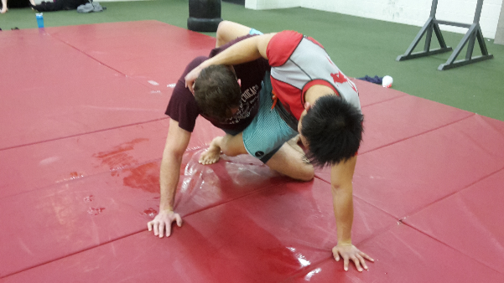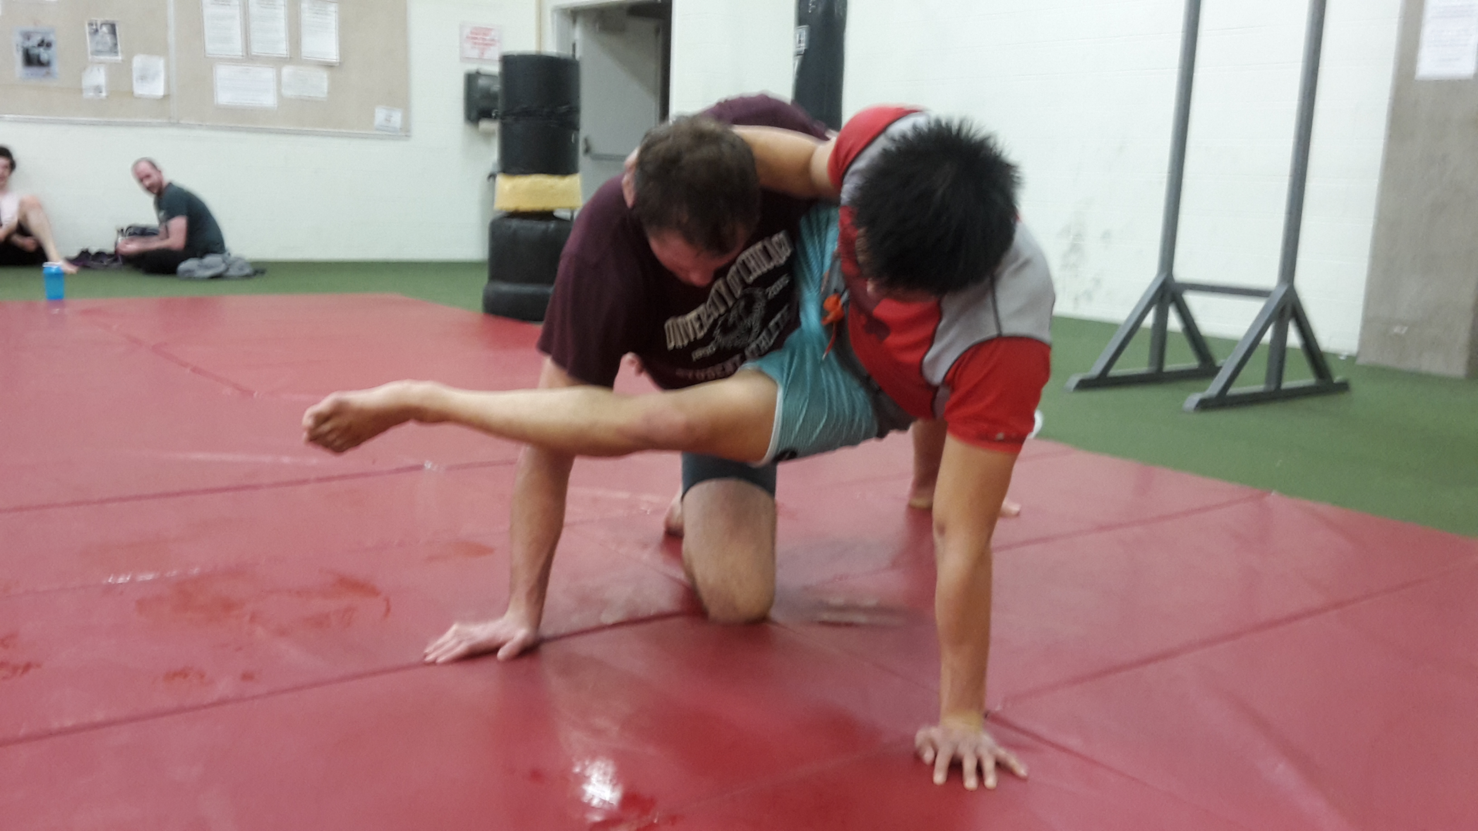

I’ve submitted countless training partners using this combination and to this day it’s one of my highest-percentage setups for the triangle. In fact, I got my first jiu-jitsu nickname, “Mr. Triangle,” after a few weeks of doing this on the regular at my home jiu-jitsu gym.

It became such a phenomenon at my gym because people *knew* what I was going for every time, but I managed to hit it anyway. That’s the power of combinations. Your opponent can know exactly what you’re going to do but still be powerless to stop it. In the above example, if your opponent doesn’t post, he gets swept. And if he does post, he gets triangled.

In the worst-case scenario, you still get a sweep and two points. And since nobody wants to get swept in jiu-jitsu, you get the triangle almost every time.

**Example # 2**

Let’s look at another example. My other two favorite submissions are the arm-triangle and spinning armbar. What I love about both of them is that they can both easily be applied from side control (synergy).

Another thing I love is that they can be used in combination.

To hit the spinning armbar from side control, you need to start by getting an underhook and placing his arm on your “bottom” shoulder. Unfortunately (for me at least), more experienced opponents are wise to this and will fight vigorously to chicken-wing their arm.

When this happens and I realize that I’m not able to get the underhook, I’ll attack for an arm-triangle instead.

Instead of trying to shove my free arm into their armpit, I’ll use it to push their elbow outwards and stick my head in the space created. This is the setup for the arm-triangle.

My opponent, in a desperate attempt to avoid being caught in a tight head-and-arm choke, will “defend” against my arm-triangle setup by slipping his arm under my face and onto my opposite shoulder.

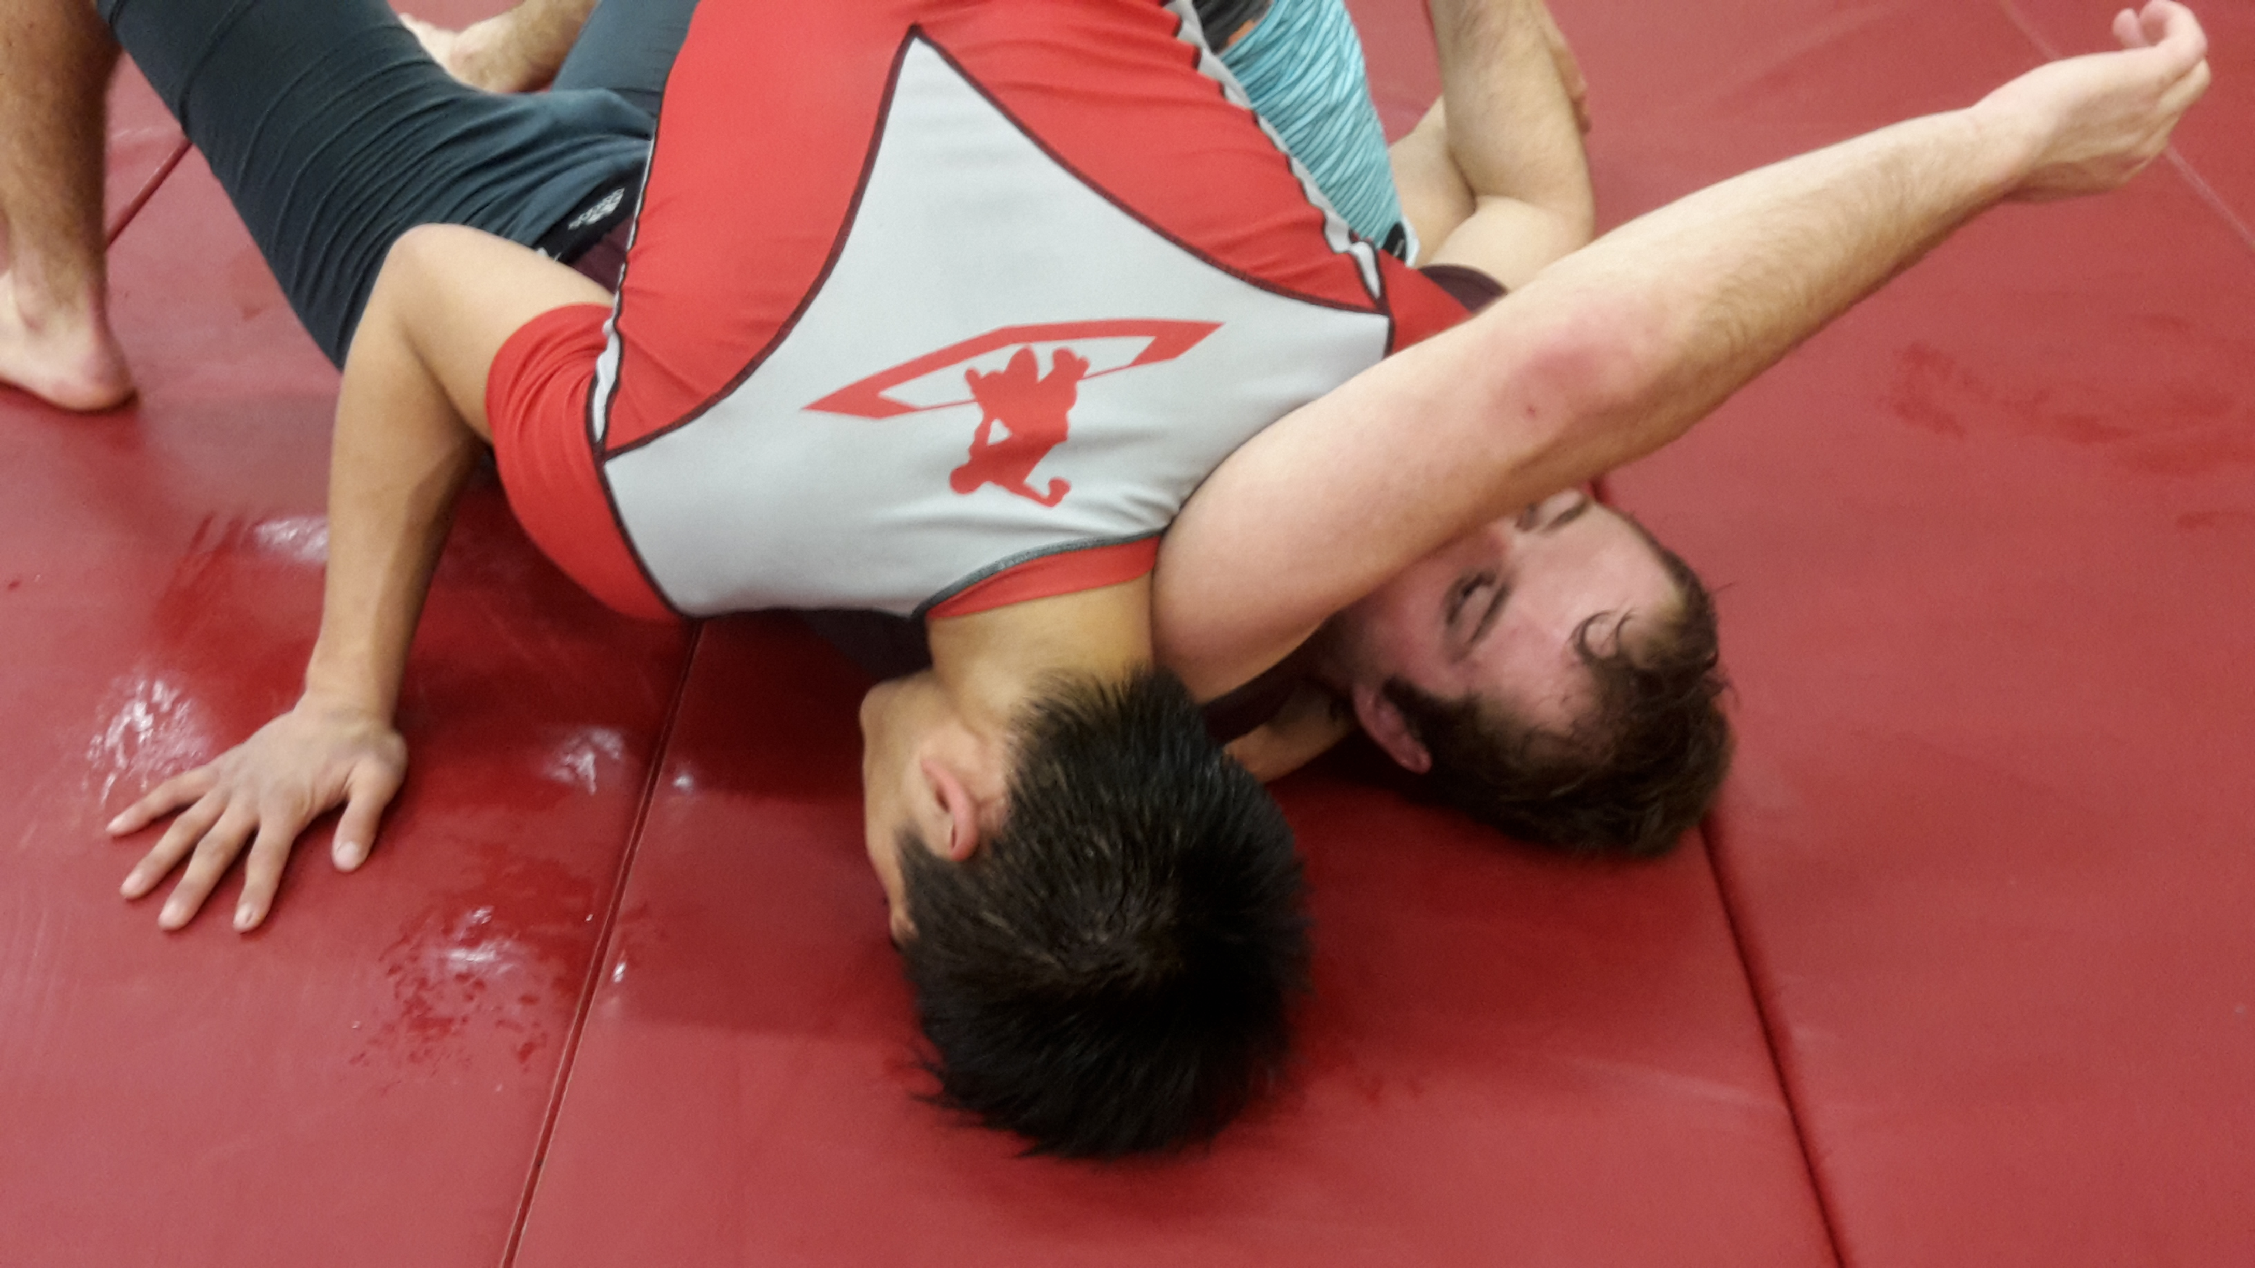 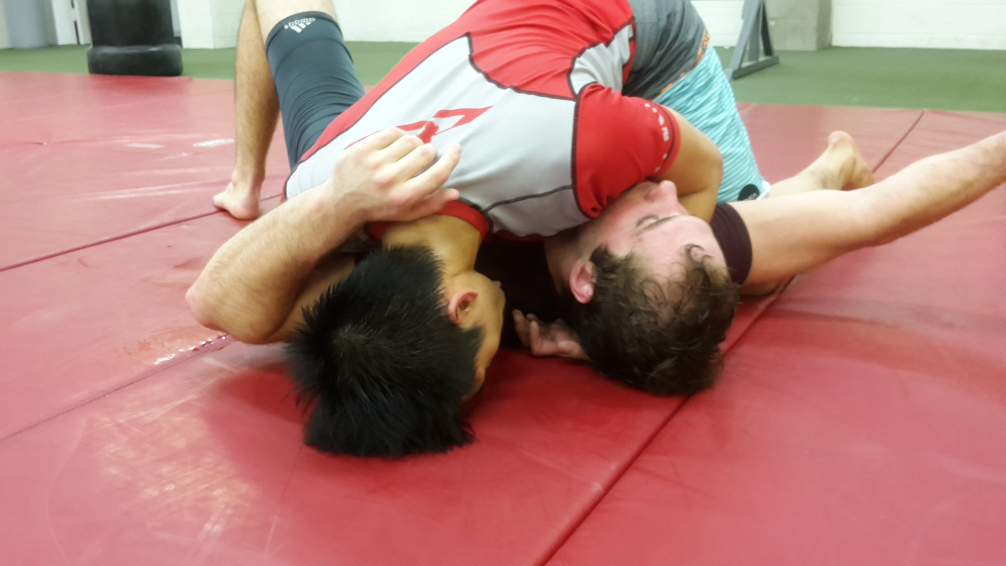

This is, if you haven’t figured it out by now, exactly what I wanted in the first place and a position from which I can hit my spinning armbar. And voila! By forcing my opponent to defend against something else (a more immediate threat of the arm-triangle), I made him give up the underhook, which exposed him to one of my high-percentage endgames.

**Other Combinations**

Those are just two examples of how I use combinations in my game.

Some other combinations I frequently use are the scissor-sweep and triangle (same principle as the hip-bump triangle), rear-naked-choke and armbar (from back control), and armbar and triangle (when they lock their hands, loop your bottom leg through to get a triangle).

Some combinations I’ve seen others use are to threaten the underhook from top side control and attack with a d’arce when they underhook as a response, attacking with a jumping triangle in response to the same thing, hip-bump sweep and kimura, and the list goes on…

A quick google search will pull up dozens of results for jiu-jitsu combination attacks. The key is not to try all of them and think that you will learn them all. Keep in mind the principle of focused training and pick and choose one or two that work for your primary submission and adapt them for you. Or better yet, develop your own combinations based on your experiences when you roll.

Most opponents you face will be focused on reacting to what you’re doing now while you’re thinking multiple steps ahead. The element of surprise leads into easy submissions.

**Summary of Combinations and Why They’re So Effective**

Start looking for ways to set up your endgame by attacking with an alternative techniques. It will take some time for you to learn how to do this against skilled opponents, but by being aware of combinations, you will start identifying opportunities when you roll and soon you’ll be on your way to developing your own killer combos.

Most of your competition, after you reach a certain point (mid-to-high level blue-belt competitions), will have the basics of defense down. They will have learned, with experience, how to defend single attacks from almost every position. By adding another step to the process and using combinations, ***you are forcing them to use their defensive skills in a way they may never have had to do so before***, and you will catch a lot of people by surprise this way. This is especially true at white-belt and lower-tier blue belt competitions.

After all, how can you defend something you’ve never encountered before?

## Synergy

If you’re an armbar master, it probably won’t do you much good to start intensively drilling footlocks. Why? Because armbars and footlocks have no *synergy*. They’re applied from completely different positions and to go for one in eschew of the other, you’d have to give up your current position and literally move to the other end of your opponent’s body.

In other words, you’d have to go back to ground zero on the offensive ladder (or close to it), before climbing up again in a different way. When transitioning to alternative offensive techniques, we want to take as few steps back as possible (you put in so much work to get there, why take three steps back when you can just take one?)

A much better technique that synergizes with armbars is the arm triangle. The arm triangle can be attacked with from virtually every position the armbar can be applied from, and the setup is similar too (you have to trap your opponent’s arm across his body). By getting good at both these submissions, you can switch between the two without giving up much ground. Ask me how I know.

When choosing alternative submissions, you want to pick ones that you can attack with while giving up as little ground as possible – ideally none.

Some examples of submissions that have synergy are triangles and armbars, armbars and arm-triangles, foot-locks and heel-hooks, kimuras and americanas, arm-triangles and americanas, armbars and wristlocks, triangles and wristlocks, guillotines and d’arce and anaconda chokes, and the list goes on…

You can apply the idea of synergy as a general principle for grappling techniques. If you do a bit of research on wrestling and judo, you’ll find that the concept of synergy can clearly be applied to throws and takedowns as well.

## Chapter Summary

* Build a *primary offensive path* that takes you to your *primary submission*. This is going to become the foundation of your overall gameplan
* Once you’ve mastered your *primary offensive sequence*, start branching out by developing alternative attacks using *combinations* and *synergy*

# Chapter 3: The Shortcut to Learning Defense – Think Mechanically

*What is my opponent trying to do… and how do I stop it?*

That is the question you should be asking yourself from now on every time someone is attacking you in jiu-jitsu, whether it’s a takedown, guard pass, or submission.

And I don’t mean that question in a superficial way.

If you’re under someone’s mount and they’re pulling your arm across your chest, obviously, they’re trying to armbar you – but think beyond the name of the technique and delve into the mechanics at work.

If you’re stuck in an armbar, think – *what’s keeping you there?* *What’s being threatened?*

The answers are:

1. Your opponent’s leg across your head. This is what prevents you from simply sitting up and turning into your opponent.
2. Your arm. Or more specifically, your elbow joint

Knowing these two facts, you now understand the mechanics of the technique in play here and you can create your own solution to defending and escaping the armbar.

People would ask me why I didn’t tap to a triangle they had me caught in, as if just squeezing your legs together will magically choke someone unconscious (it will, but only if done so in a specific manner).

There are two main ways that you can apply your understanding of the mechanics of jiu-jitsu to improve your defense:

1. Submission defense
2. Positional defense

To understand jiu-jitsu from a mechanical perspective, it helps to have a basic understanding of human biology as it relates to breaking bones and choking people unconscious. I’ll save you the research and summarize a few key points:

## Joint Locks

**Limbs are broken at the joint (the intersection of two different limbs).** For example, an armbar attacks the arm at the elbow joint. It does this by moving the arm in one direction while applying resistance in the opposite direction *at the elbow joint*.

So if you can figure out a way to move the elbow joint away from the point of resistance, you’re safe. Hence the reason one escape to the armbar is to roll into the attacker and move the elbow joint away from their hip bone (which acts as the point of resistance) and onto the floor.

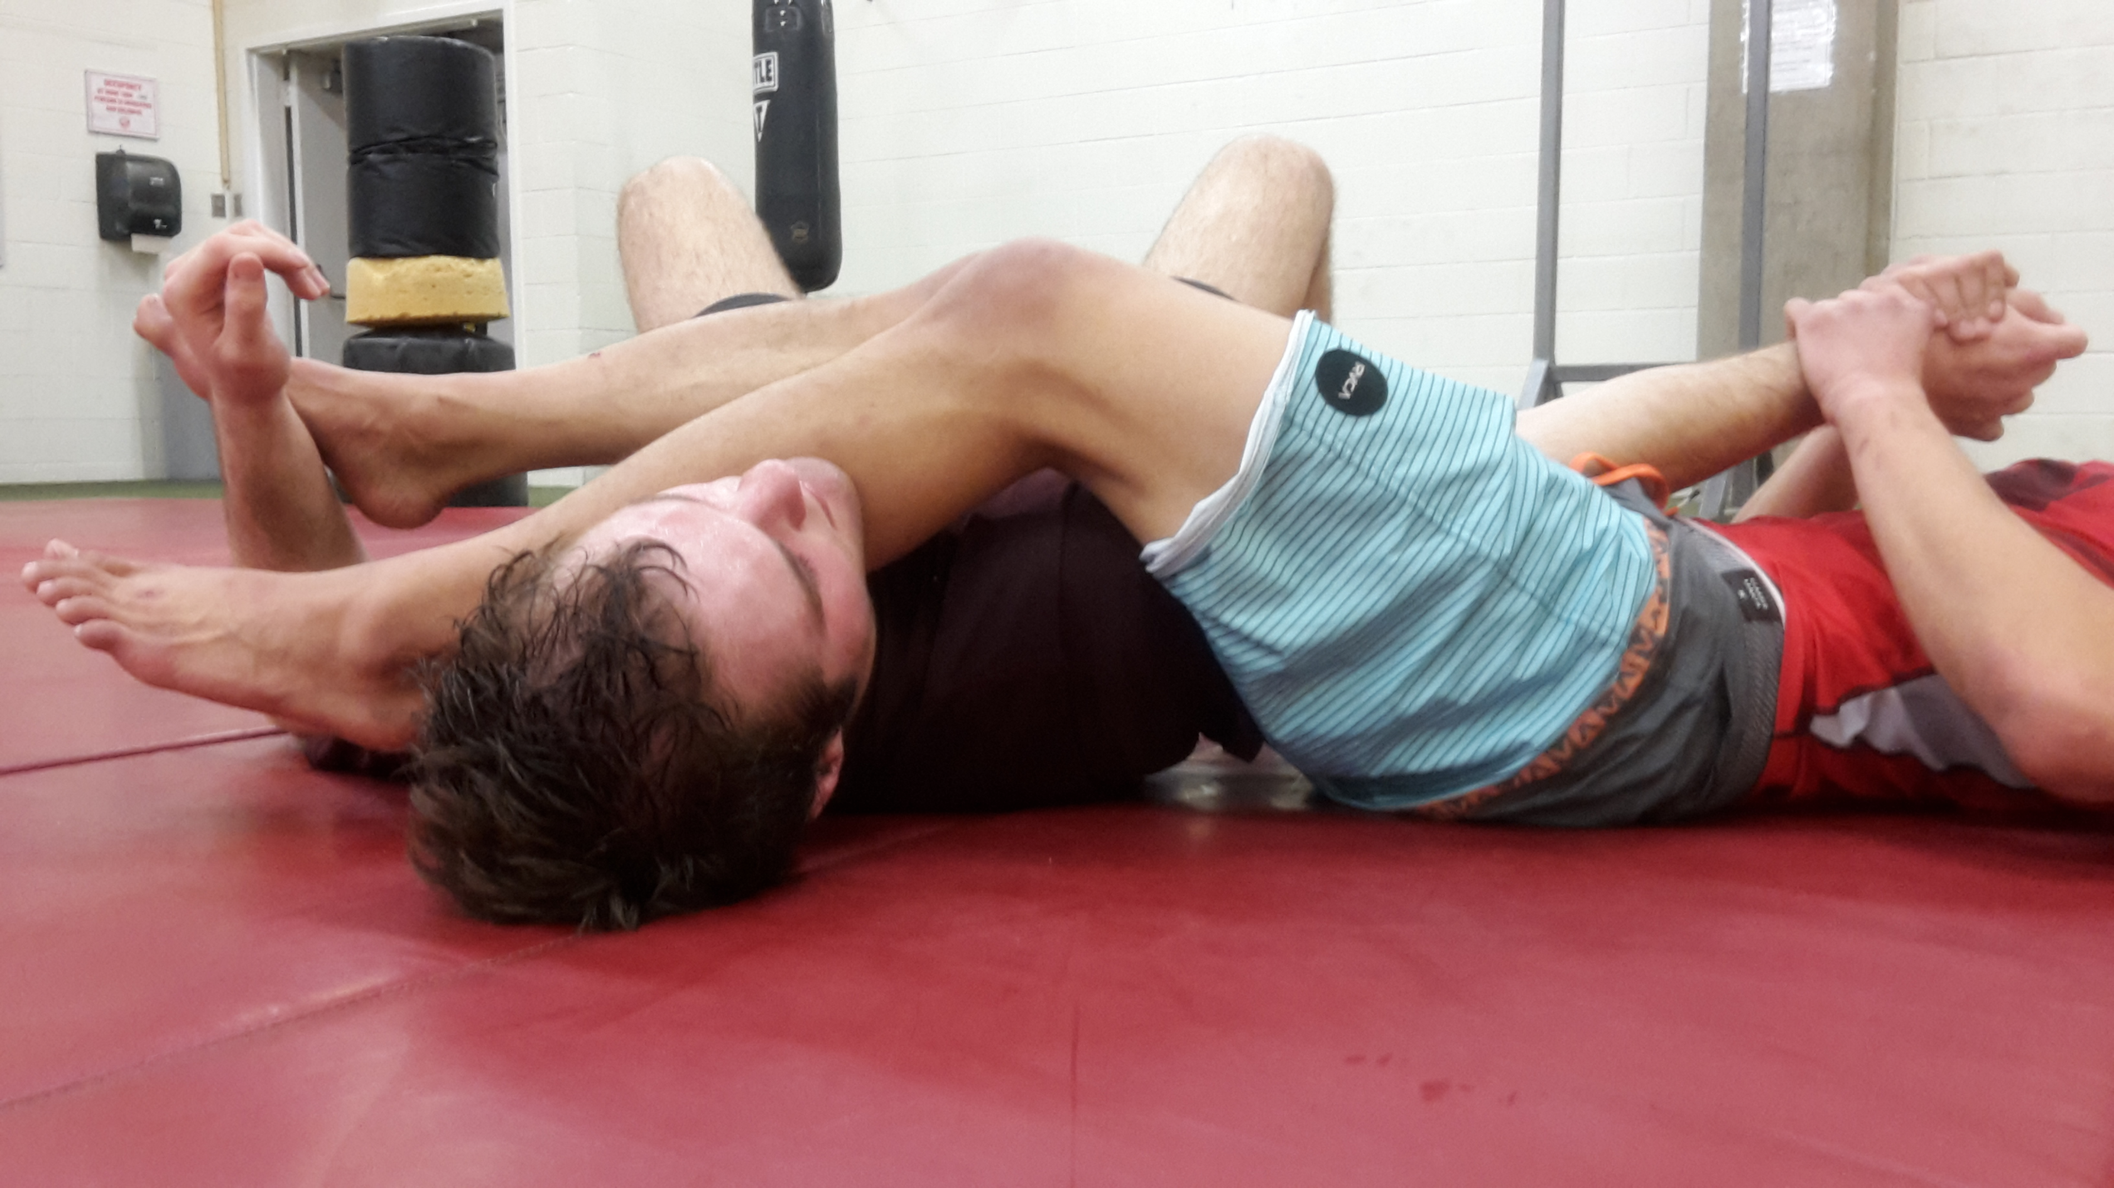 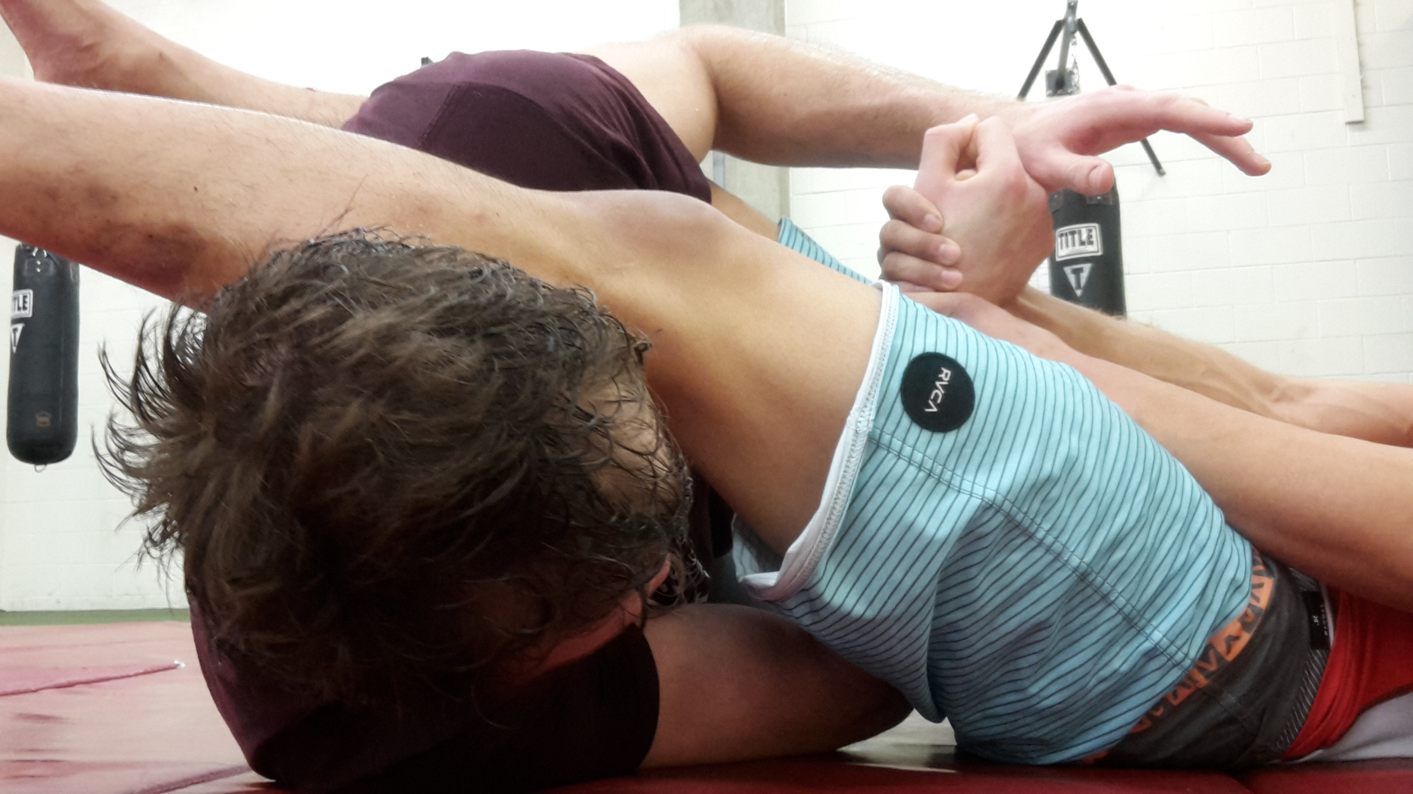

*Good for Armbar**Bad for Armbar*

## Chokes

There are two kinds of chokes in jiu-jitsu: blood chokes and windpipe chokes. We’ll go over the mechanics of both.

**Blood chokes work by cutting off both of** **your carotid arteries.** Run your fingers along the sides of your neck right under the chin and you will feel a vertical vein on each side where your pulse jumps out at you. Those are the ones. They’re responsible for delivering blood to your brain and if suppressed simultaneously, will result in you falling unconscious, or “going to sleep” after a certain amount of time (usually in the neighborhood of ten to thirty seconds).

As an interesting experiment, if you apply pressure on these two arteries with your thumbs, you’ll notice that within ten seconds or so, you start to feel slightly light-headed. Let go (obviously) when this happens, but it should give you a good idea of how blood chokes work.

You’ll notice that you can still breathe while experiencing this sensation – that’s the beauty of blood chokes. They allow you to choke someone unconscious without restricting their air supply.

Very often someone caught in a clean blood choke (one that doesn’t restrict their windpipe) isn’t even aware that they’re being choked out until moments before they go unconscious. That’s why you hear about people “going to sleep” when they roll.

Chokes that fall under this category are:

Triangle chokes, Arm-triangle chokes, Anaconda chokes, D’arce chokes (when applied correctly), Rear-naked chokes (though these often become windpipe chokes as well)

**Windpipe chokes work by cutting off your windpipe at the front of your throat.** This directly interferes with your ability to breathe, and as you can imagine (or know from experience), is quite painful. Most people tap to windpipe chokes from the pain. Very rarely does someone actually go to sleep from a windpipe choke.

Chokes that fall under this category are:

Most guillotines, Ezekiel chokes, Peruvian neckties

## Application

Now that you know how each of the submissions you’ve been taught work on a mechanical and biological level, you can use this information to your advantage.

How? Mainly, realize that the submissions you know only work if they apply pressure to specific points on the body, often simultaneously.

Let’s extract the usefulness from the theory:

**Joint-locks**: only work if pressure is applied at the joint while the limb is held steady

**Blood choke**s: only work if consistent pressure is applied to both carotid arteries (sometimes you can get away with one, but rarely)

**Windpipe chokes**: only work if pressure is applied to the front of your throat

Those four lines might be the most lines you read about jiu-jitsu if you can apply the information effectively.

Once you start seeing submissions and submission defense from the perspective of applying or removing points of vulnerability, you can become the “guy who is weirdly difficult to submit” (we all know one of those) by hacking, or finding the loopholes in other people’s technique. You can also use this information to tighten up your own offense and improve your own finish rate.

I’ll give you four specific examples of how I use mechanical thinking when I roll:

## Triangles

Type of choke: blood

Method of attack: compression of both carotid arteries via attacker’s thigh and defender’s shoulder

**Defense**

To buy time when I’m caught in a triangle, I’ll curl my trapped arm and press my elbow into my opponent’s thigh, trying to push it down as if I were trying to touch my elbow to my own thigh.

The goal of this is to create as much space between my shoulder and the side of my neck as possible, freeing up the carotid artery on that side of my neck and buying me at least a few seconds of free time.

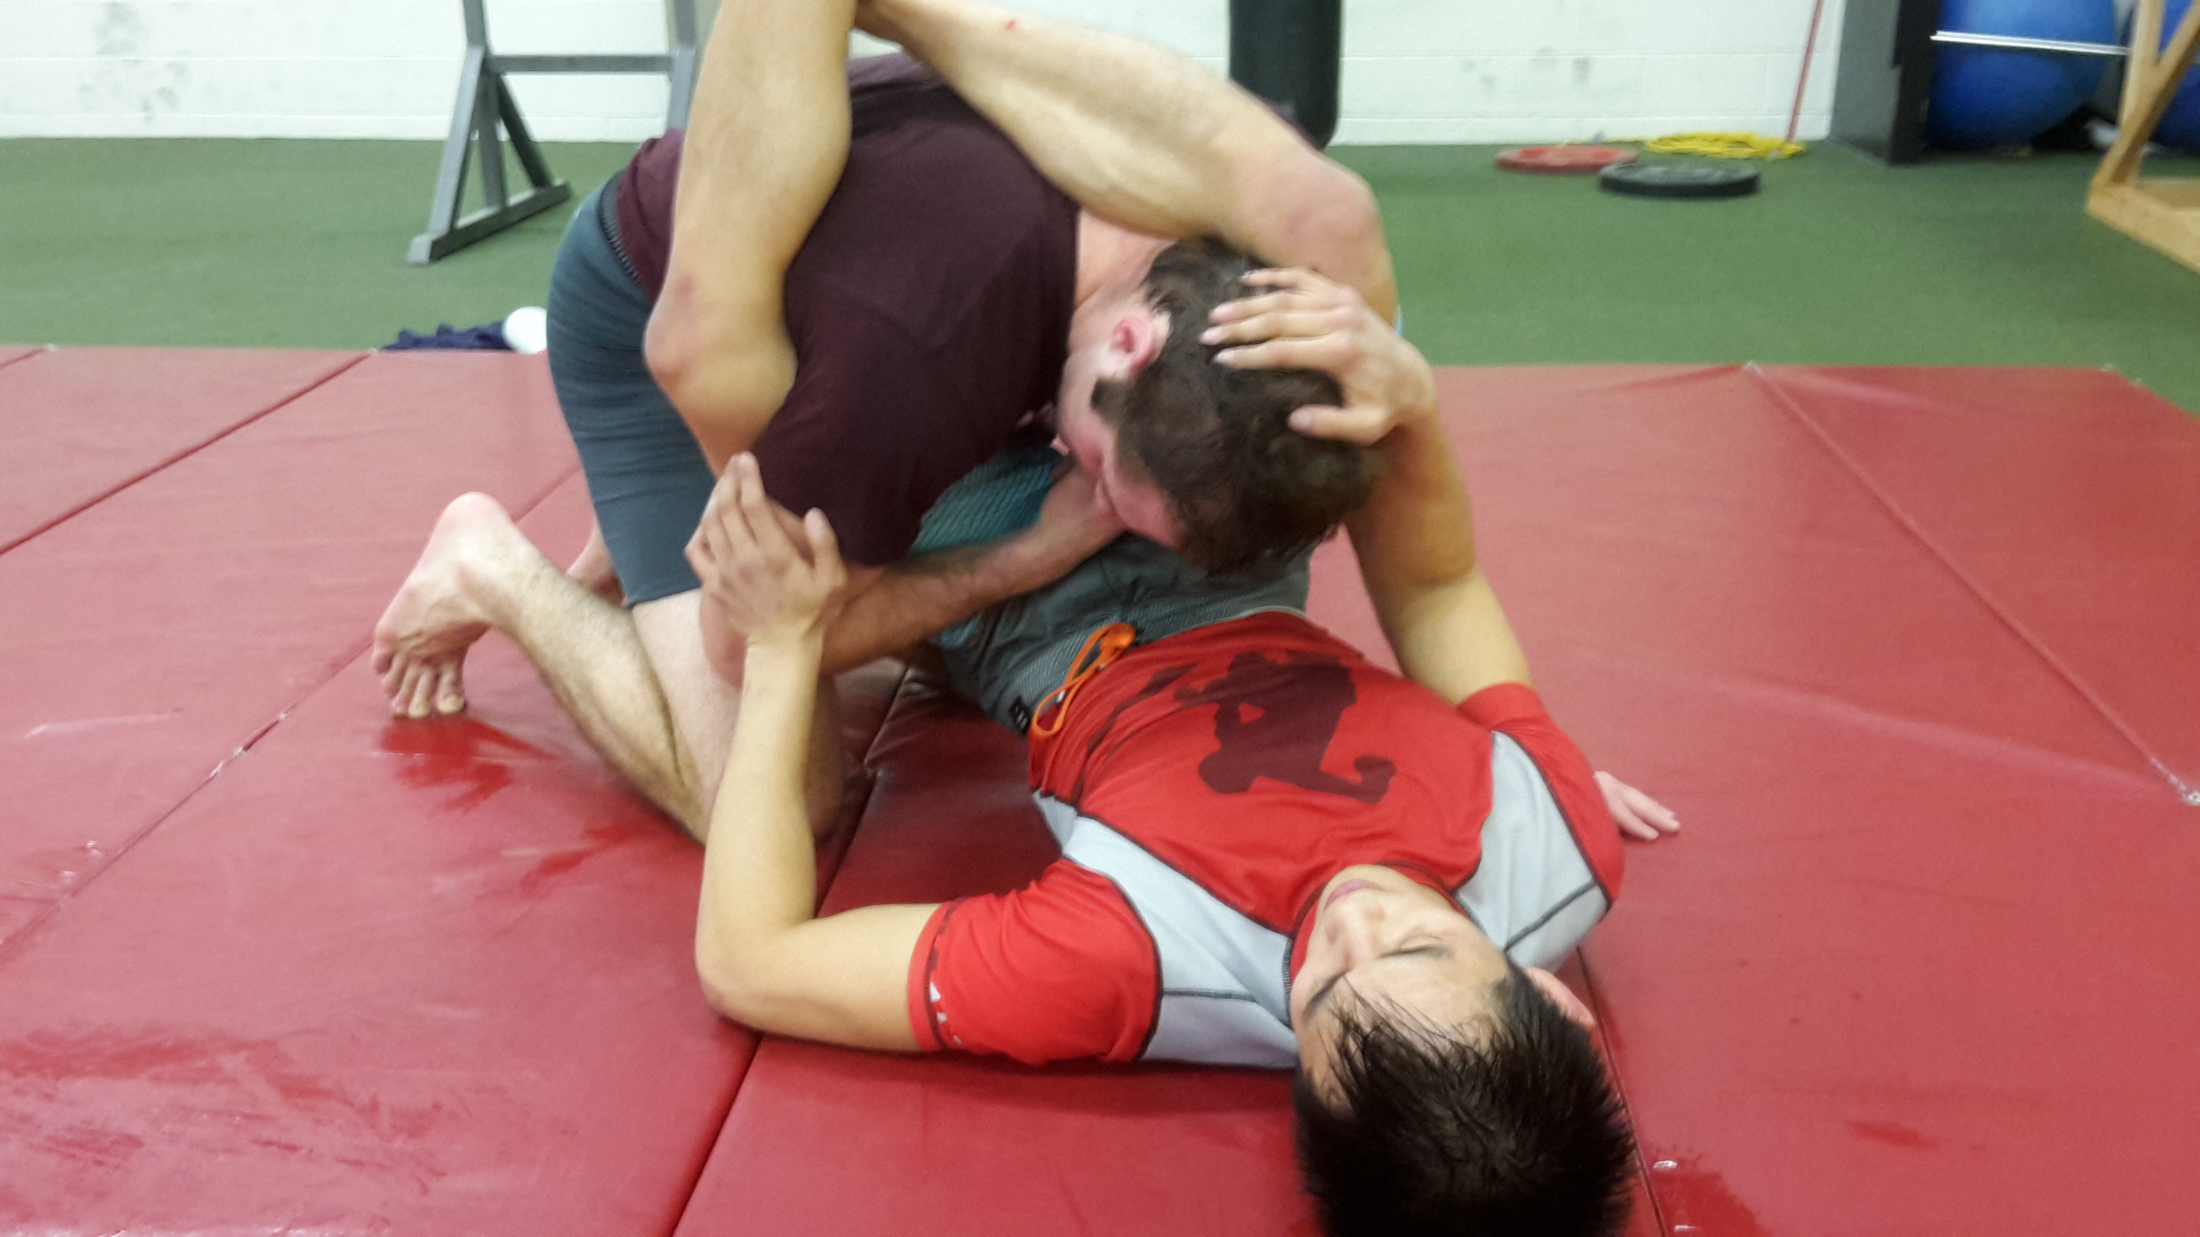

From there, I will work to wrap my arm around my opponent’s thigh and lock my hands together underneath. This creates a stable position from which I have ample space between my shoulder and neck, and from there I can work on escaping.

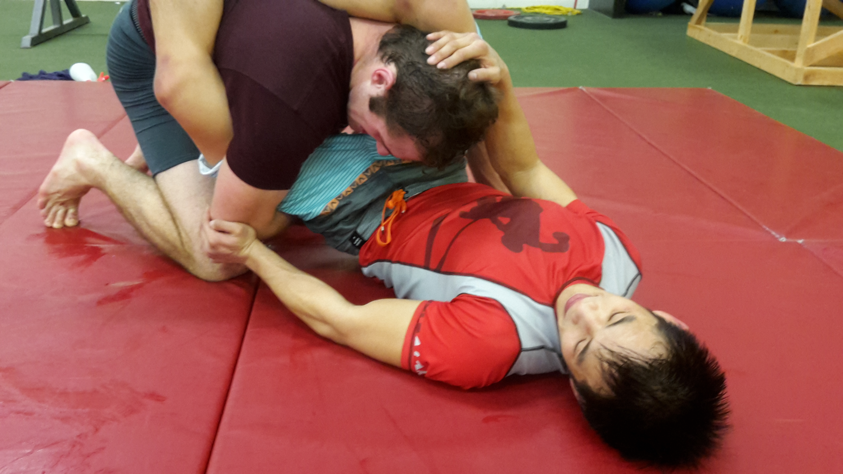

Note that these are both survival tactics for a worst-case scenario. As I’m sure you’ve heard many times before, the best way not to get tapped out by a triangle is to not get caught in one.

**Offense**

The flip side to this is that if you’re attacking with a triangle, your goal is to close that gap between your opponent’s shoulder and the side of his neck.

This is why squeezing your legs together and pulling down on the head is an inefficient way to finish the triangle. A much more effective way is to turn your body so that you are perpendicular to your opponent and rotate his shoulder into his neck using your legs.

As the saying goes, ask me how I know.

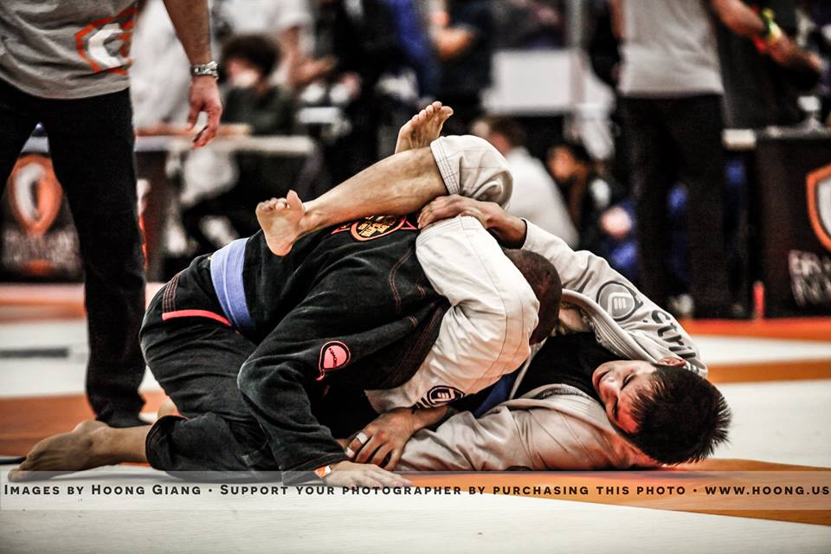

## Armbars

**Mechanical Details**

* Point of vulnerability: elbow joint
* Method of control: leg pressure on head to keep opponent from sitting up
* Submission is executed through: pressure applied by pulling arm to chest and arching backwards, counter pressure applied by hip bone

**Defense and Escape**

If there’s one technique on the ground that judokas are known for, it’s the armbar. Because you only get 30 seconds to work on the ground, judokas need a submission that’s fast, powerful and easy to apply. Just look up “judo armbar highlight” on youtube if you want to see what I’m talking about.

One of the guys at my home gym is a judo and BJJ black belt, and sure enough – his armbar game is ***tight***. He regularly taps out everyone from white to black belt, and with frightening speed.

One of my proudest moments in my development as a BJJ athlete was when I first escaped his armbar. At first, I thought this was just a fluke until I did it multiple times in the weeks following.

I was proud beyond words. As far as I knew, no one had escaped this guy’s armbar when he had it locked in.

And the way I did it is was so simple, I can’t believe I don’t see it being used more often.

Since I knew that my opponent’s leg on your head was the only thing trapping me in the armbar position, I knew that all I had to do was remove that leg – just long enough for me to sit up and escape.

Of course, that was easier said than done, since my opponent was trying to hyperextend my arm at the same time. But after playing around with different defenses to the armbar, I realized that there was a way to protect my arm *and* move his leg off my head at the same time.

I call this one the rear-naked-choke push:

-Use the rear-naked-choke grip to protect your arm (arm that’s under attack grips free arm’s bicep and curl the free arm in to keep it tight)

-This should keep your trapped arm safe while leaving your other arm free to move around (to an extent)

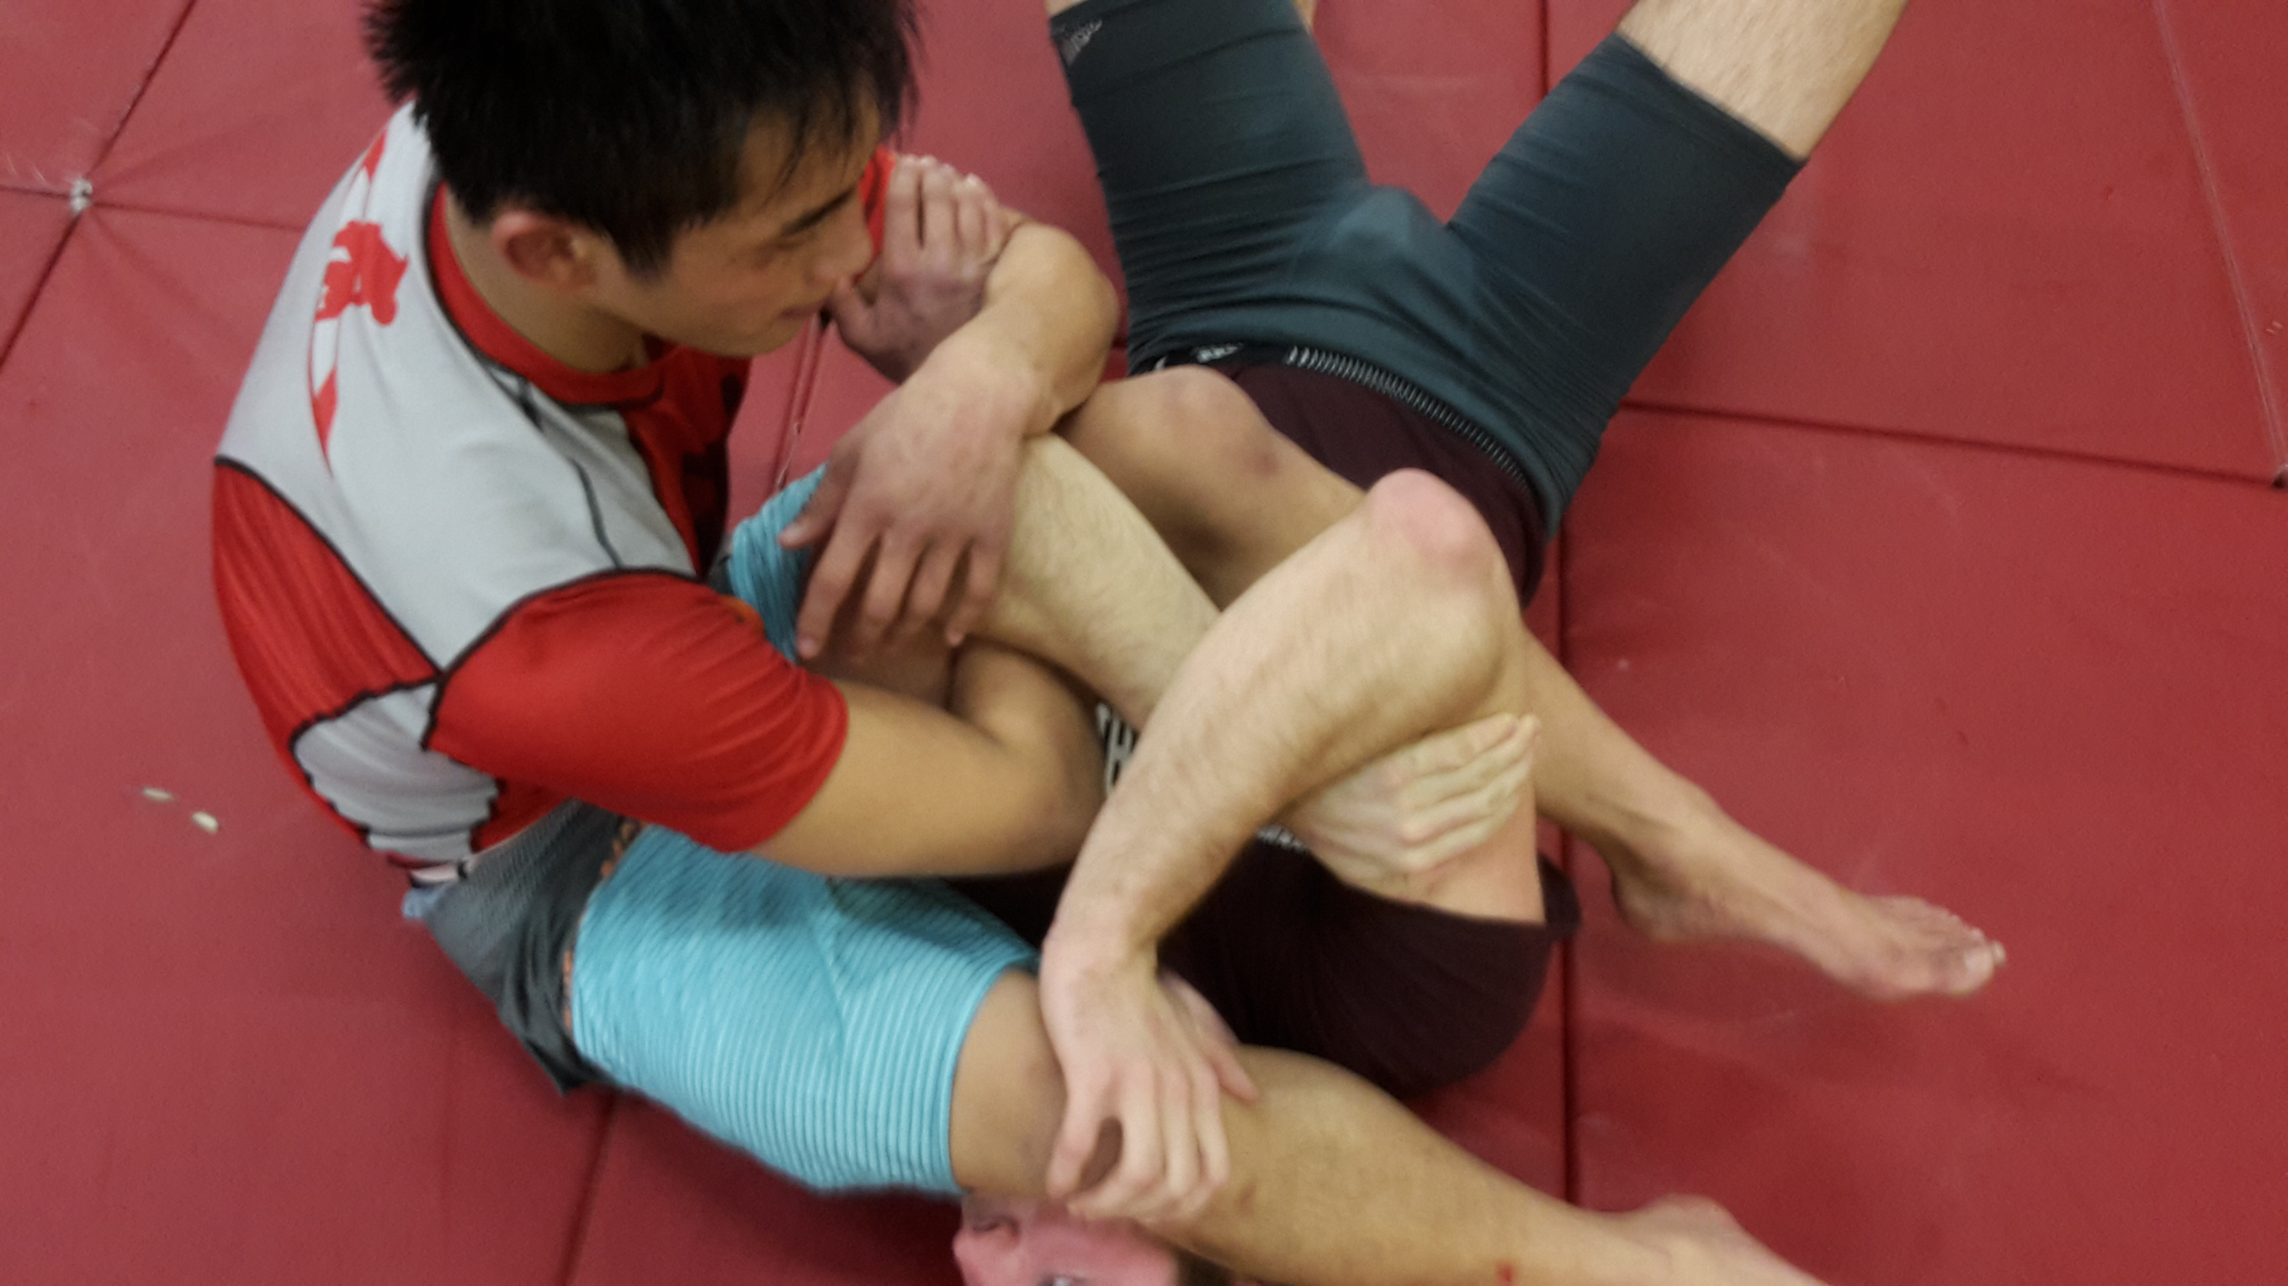

-Keeping the grip intact, use your free arm to push your opponent’s leg off your head

You might need to do a little maneuvering to make this happen. If there isn’t enough space for you to put your hand against his leg, stack your free arm on top of the other one (as if you were crossing your arms) and use this structure to push against his leg. Combine with a bridge upwards for maximum effect.

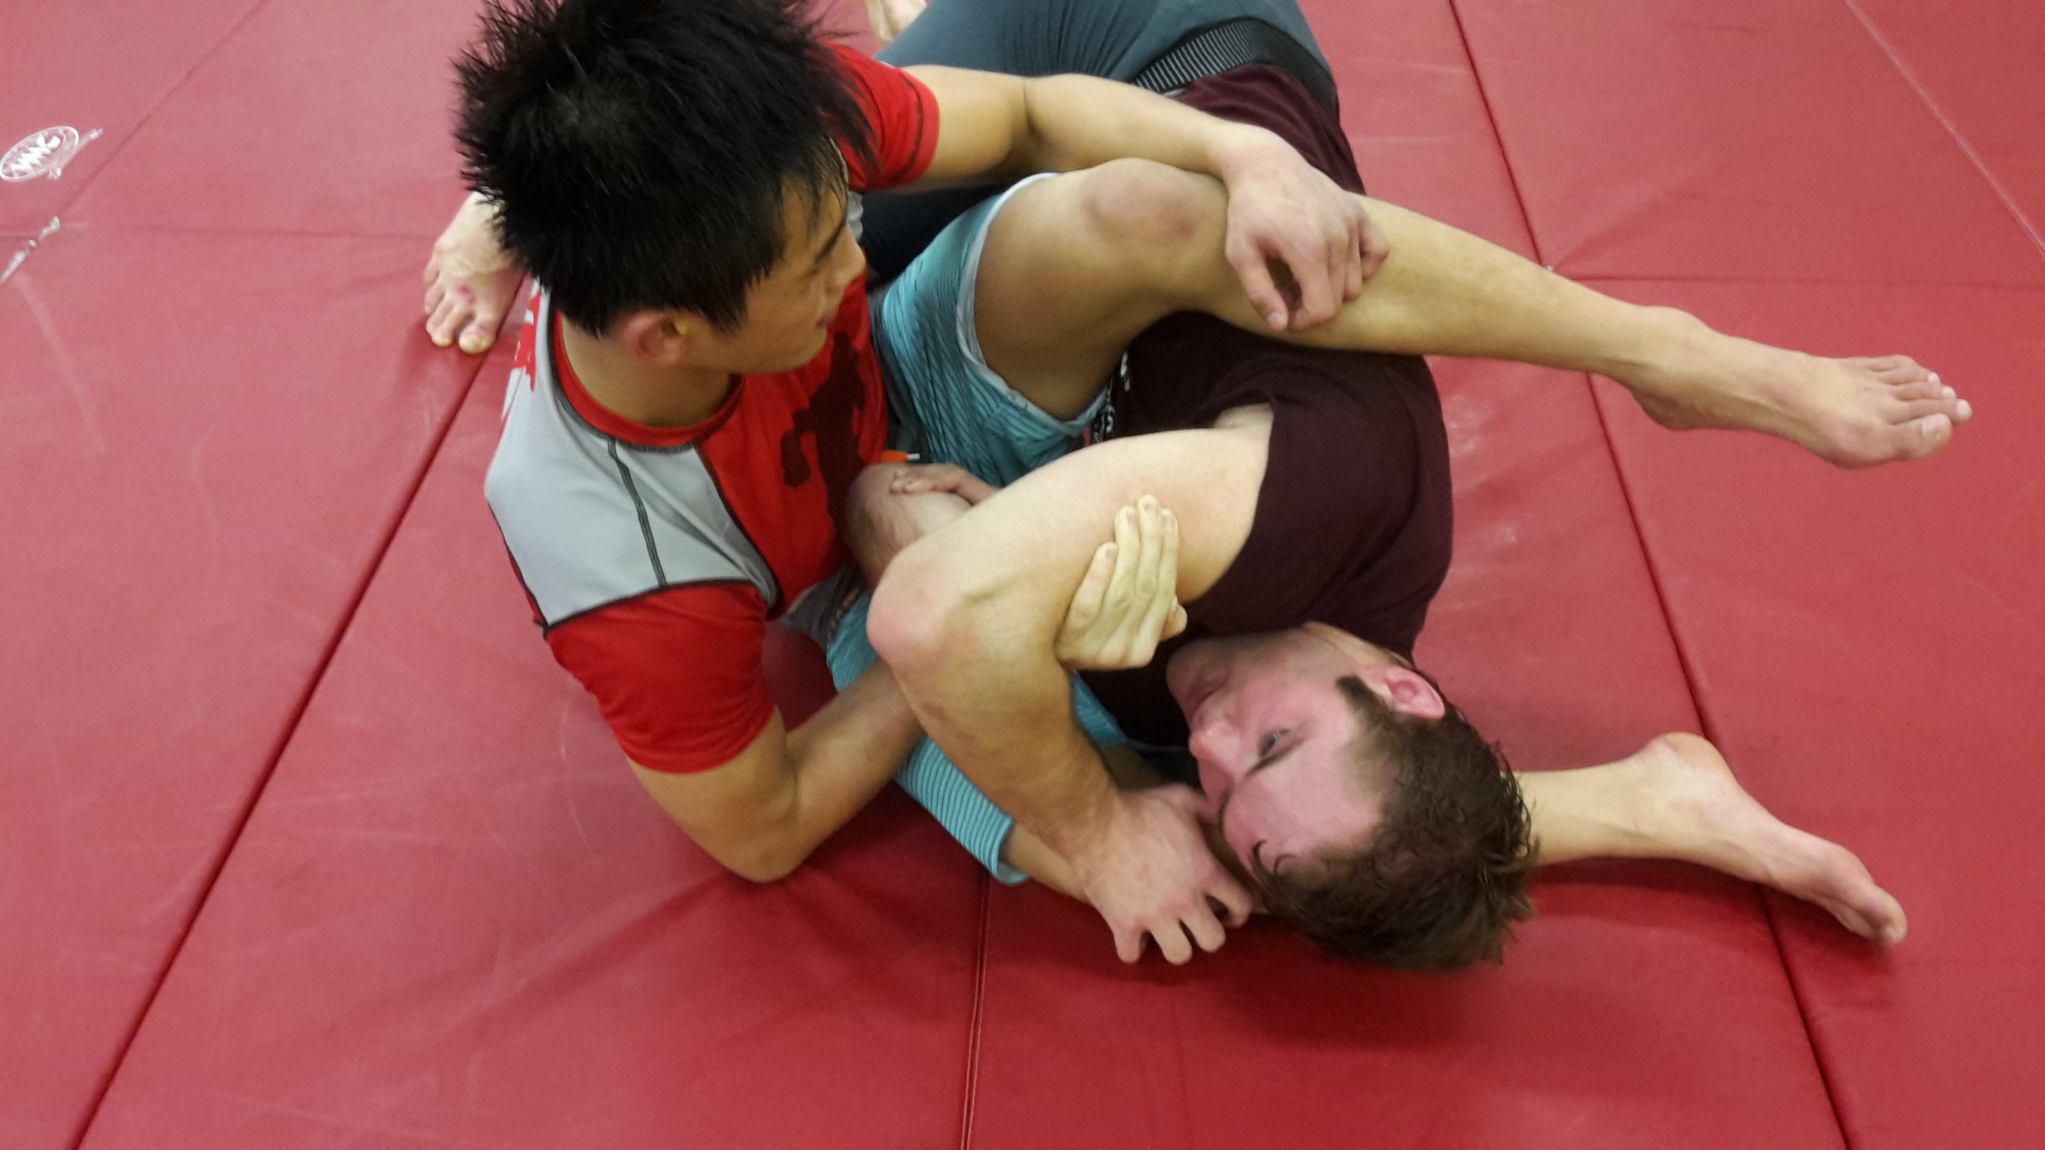

-All you need is a few inches of space to get his leg off your face for a moment – and you can sit up and land in your opponent’s guard or top side control

**Standing Guillotines**

One of the problems I encountered a lot as a white belt when I would roll from a standing start was that I would always run into standing guillotines and have no idea what to do. I couldn’t reach their legs because they would keep their hips back, and the pressure on my throat was so tight I’d tap almost immediately.

Eventually, I realized that if I turned to the side, I could remove the pressure on my throat because the blade of their forearm would no longer be perpendicular to my windpipe.

My defense to the guillotine was formed, and it looked something like this:

-Get an underhook on the side that your head is not trapped on

-Walk forward while turning to that side and deepen your underhook to maintain your sideways (relative to your opponent) positioning

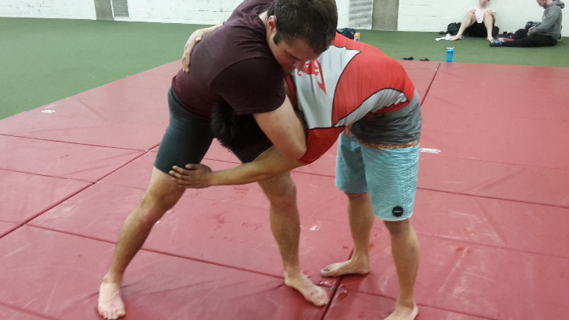-Take your opponent down and land in side control

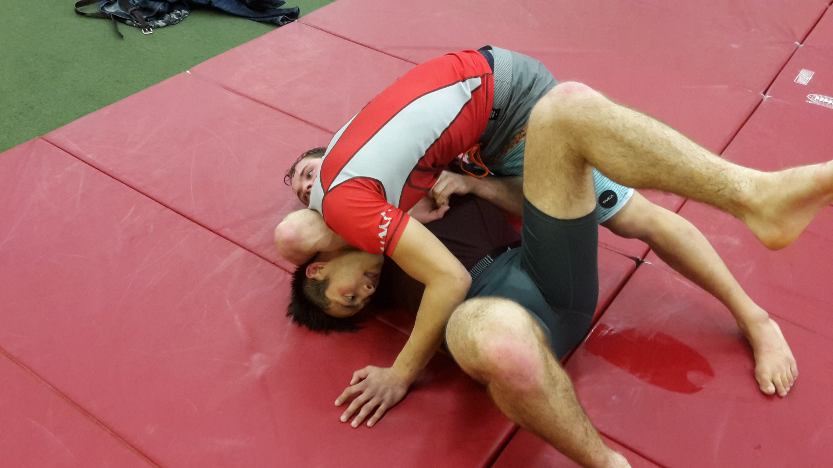

At that point, my body would be perpendicular to my opponent’s, and I would have a tight underhook on the side that they weren’t trying to guillotine me on. I later combined this with a takedown similar to *Tani-Otoshi* from judo, and was able to land in side control and in position to secure an arm-triangle a very high percentage of the time.

By thinking about what actually made the move work, I was able to reverse-engineer the technique and develop a counter that actually let me attack with my submission. Just one example of how mechanical thinking changes your game.

**Defending Against the Anaconda Roll/D’arce Choke Dump**

This is an example of how knowledge of mechanics will help with your positional defense.

The next time you’re caught in an Anaconda or D’arce choke from the front-headlock position, this is how you avoid getting dumped on the ground.

Realize that your opponent’s goal is to dump you by rotating your body onto one side (for the Anaconda, it’s the side your arm is trapped on and for the D’arce, it’s the opposite), and create a post to prevent him from doing so.

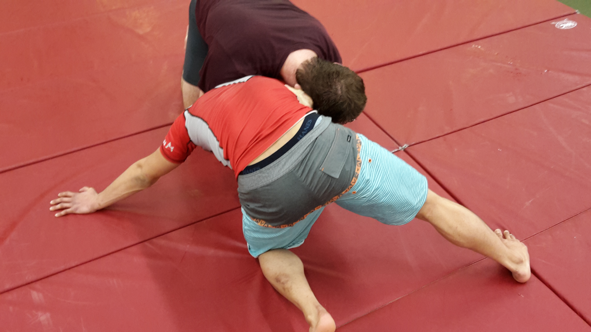

Something as simple as getting up with your leg on that side has served as an effective defense for me when people catch me in a front-headlock/anaconda choke.

**Summary**

Think mechanically and develop your own effective solutions to the problems presented to you in jiu-jitsu. Gain an edge over other practitioners who don’t know the mechanical principles behind the techniques they use.

## Chapter Summary

* Start thinking about jiu-jitsu from a mechanical perspective by asking yourself the question: “what is my opponent trying to do, and how do I stop it?” when you roll

# Chapter 4: Putting It into Practice – You Fight the Way You Train

By this point, you should have a pretty good idea of the general steps you need to take as a part-time jiu-jitsu athlete in developing an effective offense and defense. Let’s talk about how to implement everything on a practical level.

## Competition Preparation Rolls – 50% of Your Training

If your goal is to compete, at least 50% of your rolls should be “competition-preparation rolls”

During these rolls, for all intents and purposes, you’re simulating a competitive match with a couple exceptions.

You don’t necessarily have to start from the feet (though you should some of the time) and you shouldn’t try to muscle through your techniques (remember, during competition you should be relaxed, technical, and applying strength in a technical manner), but during these rolls you’re trying to win, and just as importantly, using your competition gameplan and not trying that new berimbolo entry you found on youtube.

Pick partners that can be competitive with you for these rolls, like skilled BJJ athletes of the same belt-color and higher belts.

Remember that the goal is to finish with your ***primary submission***. If you’re ahead on points and have top side-control, that’s great, but training isn’t the time to play it safe. Collect feedback on your offensive strategy by going on the offense when the opportunity is presented.

These rolls will be how you get real and honest feedback on your skill level and ability as a competitor. They will be some of your most informative learning experiences and catalyze your development as a competitor. You will learn whether your competitive gameplan works at your belt-level and if not, the necessary adjustments you have to make.

You can also use these to make an accurate prediction of how well you will do in competition. If you’re tapping out everyone at your weight and belt-level or tapping out higher belts, expect to win your next competition.

## Use Your Competition Gameplan in 90% of All Rolls

As a rule of thumb, you want to be using your gameplan that you defined in Chapter 1 and 2 in 90% of all your rolls. This is a rough percentage, and feel free to size up or down slightly if you want, but I would say 80% is the bare minimum for developing the necessary proficiency in your offensive sequence(s) to beat the majority of competitors at your skill level.

Remember the theme of this book – you need to ***focus your training*** if you truly want to bring your skill and performance to another level as a part-time athlete. You don’t have the luxury of training three hours a day, so make sure you make the most of the mat time that’s available to you.

## Rolling With Less-Skilled Partners

Rolling with partners who are lower-belts compared to you is a great opportunity to train your technical precision and reduce your reliance on strength in your gameplan. When rolling with lower-belts, you want to focus on using pure and relaxed technique to win unless they have a massive strength or athleticism advantage or they’re a wrestler (fuck those guys, you can go ham on them).

Use these rolls to get used to rolling effectively in a controlled and relaxed but effective manner. You should try to win against lower-belts, but don’t be that guy or girl who smashes them ruthlessly for a power trip (I’m sure you can think of an example). You can give ground, but don’t just let them win all the time. That teaches neither of you anything. Instead, you should see these rolls as an opportunity to improve your technical skill.

Technical skill makes more of a difference than you might think in competition – the ability to execute techniques in a controlled, precise and relaxed manner conserves a massive amount of energy in a match and prevents the “forearm-burnout” that’s commonly associated with grappling competitions.

If you can improve your ability to execute technique effectively while staying relaxed, it will be one of the biggest advantages you can give yourself in competition. While your opponent is busy tensing up and burning out their muscles, you’ll be relaxed, technical and ready to use your strength when you need to. Most BJJ athletes don’t have this mastered until they are high-level blue belts or purple belts.

**Trying New Techniques**

If you want to try new techniques, rolling with lower-belts is the time to do it. Remember that 90% rule I mentioned? Your other 10% of rolls take place here.

## Rolling is the Best Form of Practice

This should go without saying, but rolling is the ultimate form of practice for improving as a BJJ athlete, especially if your goal is to win competitions. If you can only show up to one class a week, make it open mat, or the class where you can otherwise get the most rolls in. There is no substitute for rolling.

Attempting to apply a technique once in a live roll is worth multiple reps of drilling it on an unresisting partner. Drilling is useful for developing basic muscle memory and reactions, but only live application teaches you how to deal with resistance and all the factors involved, such as how much strength to use, which muscles to tighten and which grips to use.

## Learn to Stay Technical Under Pressure

Something a lot of beginners struggle with is applying technical details that they’re aware of on an intellectual level when they’re rolling at above 50% intensity. Because you’re essentially in a live combat situation (even if no strikes are involved, grappling still feels like a fight), your natural reaction is to rely on instinct, and, instinct, at least when you first begin, is often messy and wrong.

Adrenaline will pump through your body and you will forget all about the technical details you had memorized an hour before class and afterwards, you’ll beat yourself up over it.

The key to staying technical under pressure is to first remind yourself that training is just a game.

Also remember that your mind is operating faster than reality when you’re in a high-pressure situation. If someone stacks your armbar, for example, and places a large amount of pressure on your neck, your instinct will panic and search for a way out because you feel threatened. It feels as if you don’t do something soon, you’ll get injured.

This is especially true for jiu-jitsu, which is a methodical and technical sport at the end of the day. When you’re stuck in a bad spot, your thoughts are faster than the action going on.

The key to overriding that thought process is to simply stay calm and observe your current situation. Remind yourself, when you’re in such a situation that you’re not in any danger and that the discomfort you feel isn’t actually threatening.

Though it may be painful at times, in training you’re not in any actual danger of being hurt. If you can remember this and bear the pain of an uncomfortable position for a moment, you’ll realize that there’s no reason to panic and that there is time for you to recollect the technical details you need to use instead of scrambling to escape and fumbling on what should be well-trained techniques.

This is definitely one of the things that made the biggest difference to my game as a beginner.

After a certain amount of training, this will matter less because your instinct will have caught up to technique because of the reps you put in, but before you get to that point, it is absolutely imperative that you keep this in mind.

## What to Write in Your Training Log

Hopefully, you’ve taken my advice to keep a training log from the beginning of the book.

At the end of each day, use your training log to record what worked and what didn’t during your rolls as well as what you’re going to do better next time. Keep an updated document that details your competition strategy and update it according to the results you encounter.

## Chapter Summary

* 50% of your rolls should simulate competition
* When rolling with lower-belts, stay technical and use as little strength as possible. If you want to try new techniques, this is when you should do it
* Use your gameplan and primary offensive sequence in 80-90% + of your rolls
* Learn to stay technical under pressure
* Rolling is the most valuable form of practice – prioritize opportunities to roll live when scheduling your training sessions
* Write down three things in your training log after each practice: what worked, what didn’t, and what you will improve on for next time

# Chapter 5: Competition Mindset

Hopefully you’ve found this book useful as a general development tool for your jiu-jitsu. I’ve gone into elaborate detail on principles that I’ve found invaluable to my game after three years of training as a part-time athlete. But since this book’s title starts with “How to Win Competitions”, let’s delve into some competition-specific material.

## Stay Relaxed – You’re Just Rolling With Someone New

The number one takeaway from this section should be to ***stay relaxed***. One of the most helpful mindset tips I’ve found is to treat matches in competition as if you’re rolling with someone new.

Just imagine someone new showed up to your gym one day during open mat and asked if you wanted to roll.

You wouldn’t be nervous right? After all, it’s just training and nothing is on the line. Hard as it may be, that is how you should see matches in competition as well.

Why? Because physically, matches in competition and training are the exact same. If you’ve been following my advice and simulating competition matches when you roll, *you are about to do the exact same thing but with a different person when you step onto the mat at a competition.*

Sure, a few tiny details might be different, like starting on the feet and limitations on what techniques you can use. But physically, everything else is the exact same.

You’re fighting someone with two arms and two legs who is just another human being. They will get tired if the match goes on for long enough and if you bend their arm or squeeze their neck in the right way, they will submit or be severely injured. Too many beginners overlook this seemingly obvious set of facts and imagine their opponents in competition to be monstrous athletes much tougher than they actually are.

## Trust Your Gameplan

The second important point to remember is to **trust in your gameplan.**

Trust that the gameplan has been adequately drilled and embedded in your body and that when you compete, you will just act. You’ve removed any uncertainty in your choices by coming up with a well-defined gameplan beforehand. You will go in there and you will execute your gameplan, and your opponent will try to stop you, but you know how to respond to anything that he or she does.

This is what it means to automate jiu-jitsu – you make it so that you remove any conscious decision-making during your matches and your body just reacts based on what you’ve drilled over and over and over again. This relieves an unbelievable amount of pressure since you know that all you have to do during the match is execute what your body already knows.

By doing this, you will enter a “flow state” where you are grappling unconsciously and you can save your conscious efforts for applying strength where it counts, thinking multiple steps ahead, and executing the fine technical details that make for a beautiful display of jiu-jitsu.

## Mental Preparation for the “Big” Day

On competition day, this is a foolproof way I’ve found to prepare myself mentally and destroy any remaining nerves.

When you wake up in the morning, hours before you actually arrive at the venue to compete, imagine that you’re on the mat and about to compete.

Visualize the arena and the mat you’re standing on. Maybe your coach, friends, and training partners are watching. Maybe there’s a crowd. Visualize the referee about to signal go, your opponent in his or her stance facing you, and slapping their hand to start the match.

That’s as far as you have to go.

Feel your body and mind’s reaction to the anticipation of competition. Feel the slight tingle in your fingers, the pit that opens up in your stomach, the rush of adrenaline, and become used to all of it.

You can imagine the actual fight too if you want, but that’s not necessary for this exercise.

The idea is to convince yourself that you’re ready to compete long before you actually have to compete, so that your mind flips the “ON” switch a few hours early.

That way, when it’s actually time to compete, you’ve been mentally prepared to do it for a while, and stepping onto the mat brings no further anxiety.

The key here is to reduce the anxiety shock when it’s go time. ***Anxiety shock*** is what I call the sudden burst of nervousness that occurs to most beginners when the competition starts and it’s go-time. It’s one of the largest energy-killers and the main source of “competition fatigue”.

## How to Avoid Negative Visualization, or “Disaster Dreaming”:

All too often, beginners associate competition with fear. Maybe it’s due to the fact that competition brings increased pressure in the form of family, friends, training partners and coaches watching, or the fact that competition is understood to be an “all-out” roll (though if you’ve done what I’ve described in Chapter 4 and simulated competition in at least 50% of your rolls, you should be used to this).

For whatever reason, competition is a large source of anxiety for many and anxiety tends to make people imagine worst-case scenarios. You might imagine getting dominated for a humiliating decision loss, or getting taken down and submitted in the first few seconds of the match.

This can be seriously debilitating to your psyche and even lead to some athletes not competing at all out of fear.

I used to do this myself sometimes until I figured out the perfect response.

For every worst-case scenario you imagine, incorporate it into your gameplan if it isn’t already in there, and imagine yourself taking the right actions (as dictated by your gameplan) to get out of that situation and get to *your* *endgame*.

The idea here is to internalize the fact that jiu-jitsu is a sport where you can literally win from anywhere.

Sure, you might get double-legged in the first second of the match. Not a big deal. Stay calm, respond according to your gameplan and get to your endgame.

## My Story: Winning the Largest Jiu-Jitsu Competition in Chicago

I’ll share a personal experience to end this book off. When I competed in the IBJJF Chicago Spring Open in 2015, it was the largest tournament I had ever done. There were 24 competitors in my bracket and some of them were from schools as far as out of state and Canada.

I had been training about once or twice a week leading up to this for the previous three months, balancing a busy academic schedule and a job search with intermittent jiu-jitsu practices.

One of these training sessions was done with fellow university students at our weekly university practice for the “Grappling Club” that I’d started at the beginning of the school year. It was nothing more than a few students getting together to roll and burn off academic-related steam once a week. We were all white-belts and most of us had never even trained at a real jiu-jitsu gym.

The other training session was done at the open mat of a gym about an hour north of where I lived, called *Valko BJJ*. I traveled there by train every Saturday to get two hours of mat time in.

By all objective measurements, I was not well-prepared to compete in what was the largest BJJ tournament in Chicago. In fact, I wasn’t even going to register until some of my training partners at Valko’s told me that I should. So I signed up and paid the fee.

On March 28th of 2015, I walked into Chicago State University for my first IBJJF tournament. It was my fourth jiu-jitsu competition overall, so by then I had collected some competition experience.

I remember facing off against my opponent in my first match. He had a white gi, was built rather slim, and stood slightly taller than me. We slapped hands and started fighting for grips.

I was still trying to get the grips I wanted when my opponent stepped in to close the distance. The next thing I knew, I was flying through the air – the recipient of a perfectly executed judo hip-throw.

I landed with my back flat on the mat, slightly winded, and at that moment I knew that I had two ways to process what had just happened. I’m going to outline the mental trains of thought that I would have taken in either case:

1. I could let the fact that I had just gotten tossed like a ragdoll affect my game and consider all the implications that came with it:

*Damn, that was fast. Off to such a bad start already. If his standup is so good, he must be a great grappler. Here he comes, I’d better be careful. Come on Matt, don’t screw up… don’t screw up…*

**OR**

1. I could selectively forget what had just happened and “reset” the match in my mind.

*Ok. I’m on the ground. He hasn’t passed my guard, but he’s trying to. I’ve been here before and I know what to do. Work towards my endgame.*

I don’t think I have to tell you which train of thought I chose to take.

Had I chosen the first one, I might still have won. But regardless of the result, it would have made the match unnecessarily difficult – I likely would have wasted energy and executed sub-par technique in an attempt to compensate for being thrown in the first few moments of the match.

*My actions would have been dictated by my emotional response to getting thrown – fear, anger, and the need to “make up” for what had just happened.*

I would have fumbled on otherwise well-trained techniques and applied too much strength in executing precise and technical movements. And as a result, the match would have been much sloppier and more tiring than it should have been.

In a worst-case scenario, I would have lost against an opponent I knew I could have beaten and been frustrated with myself for losing in the first round.

What I did instead was something I had learned after competing in three jiu-jitsu competitions – I stayed calm, reminded myself that my gameplan had accounted for this scenario, and worked towards my endgame.

I ended up tapping out my opponent with a triangle less than two minutes later and walked off the mat relaxed and fresh, ready for my next match.

I won my next four fights in similar fashion.

I hope this gives you an idea of why proper strategic preparation is so important, and why I dedicated three quarters of this book to the simple subject of creating a gameplan.

*Having a well-thought out and practiced gameplan keeps you focused and confident when things don’t go your way.*

A lot can happen in competition that you don’t expect.

You will face opponents and skillsets that you haven’t necessarily encountered before. Add to the fact that competition is usually an amplifier of nerves, physical tension, and anxiety, and you have a recipe for underperformance and disappointment for most beginners.

Even professional athletes struggle with the mental aspect of competition.

If you’ve armed yourself, however, with an effective gameplan and an optimal, ***focused***state of mind, you will be able to remain composed and operate at your most effective state no matter what happens – something that your opponent will likely not be able to do.

There is nothing more unnerving in competition than facing someone who is perfectly relaxed but knows exactly what they’re doing, and executes techniques with the precision and fluidity of someone who’s been there a hundred times before.

That’s what you become when you combine effective preparation and execution.

And when you reach that state, competition transforms from something that you’re anxious and nervous about to something that you’re looking forward to. There will always be a small amount of nerves, but it will manifest itself more as excitement than anxiety. You’ll find yourself thinking that you can’t wait to show people what you’re capable of rather than being nervous of how the match will go.

And that’s when competitive jiu-jitsu becomes fun.

## Chapter Summary

* Stay relaxed when you compete. After all, you’re just rolling with someone new
* Trust in the gameplan that you created for yourself in Chapters 1 and 2
* To avoid anxiety shock, visualize the moment of competition hours before it actually happens
* Every time you imagine a negative outcome in a match, visualize yourself taking the necessary steps to turn the situation around for a win

# Ending

Jiu-jitsu is a great sport, and learning how to successfully compete in it has taught me so much more than how to choke people out with my legs and break their arms on a mat. It’s taught me a recipe for success that I believe can be applied to any field that demands intense focus, effective planning, selective skill development and the ability to execute under pressure.

I sincerely hope that you found this book useful in your own journey as a jiu-jitsu athlete, whether you’re a hardcore competitor, hobbyist, or somewhere in between, and that you gain something lasting from the beautiful sport of grappling.

Matt

1. By the way, this principle applies to any other aspect of jiu-jitsu that has an offense/defense component (where you’re trying to do *X*, and your opponent is trying to stop you from doing *X*).

   I’m using submissions because they’re the clearest example and the focus of this section, but you should apply this idea to your takedowns/guard-pulls, guard-passing, choice-of-control position, and even to defensive techniques like escapes or guard-retention.
2. Your **finish rate** is defined as how often you get the tap when you have the submission **locked in**.

   Using the mounted armbar as an example, I would consider it **locked in** the moment you have a leg over their face and the “target” arm hooked. All you have to do is break their defense and extend the arm against your hip without letting them escape. If you can do this at least 95% of the time, you’ve *mastered* the armbar.

   As another example, a triangle is **locked in** the moment you pass one leg over your opponent’s arm or shoulder. If the triangle is your primary submission, there should be no excuse for not getting the tap from there.
3. I became known in multiple gyms as “the triangle guy” and was able to tap out higher belts on the regular with my triangle choke.